**Learning Objective**

We are learning how to solve a natural world problem by using and applying our skills and knowledge of area.

**The Problem:**

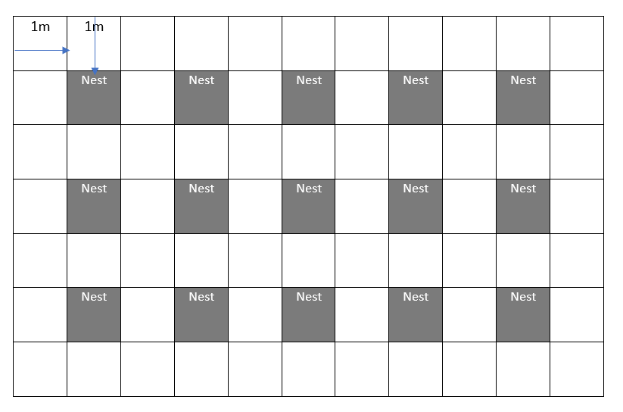

River chub live in the Mississippi river. In one area of the river, their nests have a diameter of 1 m.

**The stretch of river is 21 m long and 11 m wide.**

There is a gap of 1 m between each nest and a gap of 1 m on each bank.

(**Note:** The picture opposite does not represent the size of the river stretch that you will need to calculate in order to answer the questions below.)

1. **What is the area of this stretch of river?**

**Answer: ___________**

1. **What is the area taken up by the nests?**

**Answer: ___________**

1. **What is the area of the rest of the river?**

**Answer: ____________**

1. **How many nests can fit into this area?**

**Answer: _____________**