

**Learning Objective**

We are learning how to solve a natural world problem by using and applying our skills and knowledge of area.

**The Problem:**

River chub live in the Mississippi

river. In one area of the river

their nests have a diameter of 1m.

**The stretch of river is 21m long**

**and 11m wide.**

There is a gap of 1m between each

nest and a gap of 1m on each bank.

(

Picture does not show size of the

river)

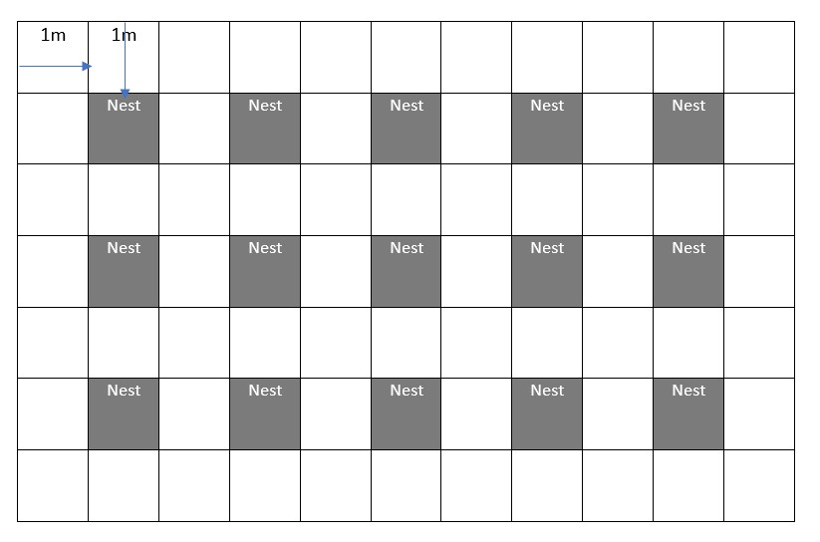

**1. What is the area of this stretch of river?**

# Answer: ___________

1. **What is the area taken up by the nests?**

**Answer: ___________**

1. **What is the area of the rest of the river?**

**Answer: ____________**

1. **How many nests can fit into this area?**

# Answer: _____________