**Learning Objective**

We are learning how to solve a natural world problem involving the relative sizes of two quantities, where missing values can be found by using integer multiplication and division facts.

**The Problem:**

The distance between a leopard and a baboon is 1.5km.

A tree, which is between the two animals, is four times further from the leopard than from the baboon.

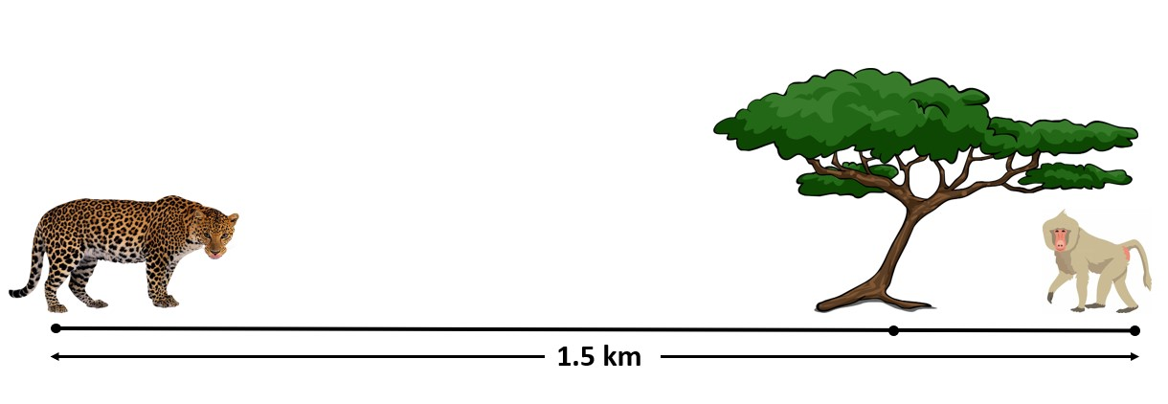

Johannes says, *‘The baboon is 375m from the tree as that is one quarter of the distance.’*

Do you agree with Johannes? Explain your reasoning.

How far away from the tree is

|  |
| --- |
| m |

1. The leopard

|  |
| --- |
| m |

1. The baboon