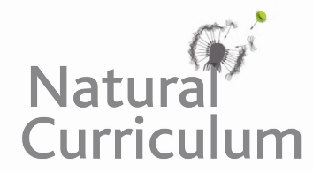**Learning Objective**

We are learning how to solve a natural world problem by using and applying our knowledge of long multiplication and converting units of measure.

**The Problem:**

|  |  |  |  |
| --- | --- | --- | --- |
|  | **Number of eggs** | **Incubation period (in weeks)** | **Age of independence (weeks)** |
| **Small species** | Up to 6 | 3 | 6 – 12 |
| **Large species** | 2 | 6 | 10 – 14 |

The female hornbill is fed by the male throughout the incubation period as well as after the eggs have hatched. Some males make up to 70 trips a day bringing geckos, seeds, insects, frogs, slugs, berries and occasionally snakes.

**What is the least number of trips a small male would make?**

**And a large male?**

**What is the greatest number of trips a small male would make?**

**And a large male?**

**Recording:**

**Answer: ___________________________________________________**