**Learning Objective**

We are learning how to solve a natural world problem by using and applying our skills and knowledge of measurement, distance and time; number and multiplication.

**The Problem:**

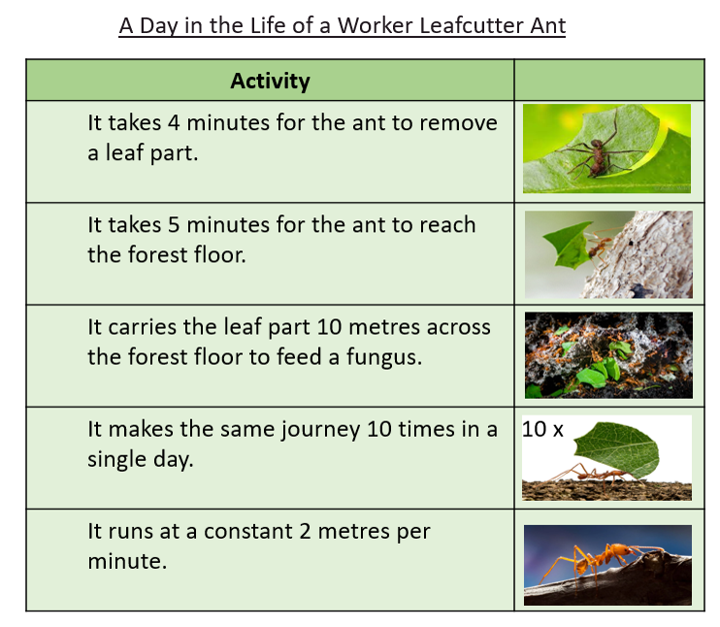

The ‘Day in a Life’ information (opposite) shows just how busy leaf cutter ants are cutting and carrying leaf parts.

Use the information to answer the following questions:

1. **How far must the ant travel from leaf to fungus and back again?**

**Answer: ___________**

1. **How long does it take the ant to remove a leaf part, take it to the fungus and return to the original leaf?**

**Answer: ___________**

1. **How many round trips will the ant make in 4 hours?**

**Answer: ____________**

1. **How long will it take the ant to take 10 leaf parts to the fungus and how far will it have travelled?**

**Answer: _____________**