**Learning Objective**

We are learning how to solve a natural world problem by using and applying our knowledge and skills of number, fractions, decimals and percentages.

**The Problem:**

The table below shows the changing population of Ridgway’s hawks over a 3-year period. It was based on the following data facts:

* There are **250 pairs** of Ridgway’s hawks left in the Dominican Republic.
* Each pair of hawks lays **2 eggs** per year.
* Only**1/5**of the chicks born each year survive botfly infestation.
* Each year,**10%**of the entire population of Ridgeway’s hawks die from other causes.

**Using these facts, can you complete the table below for the 3-year period?**

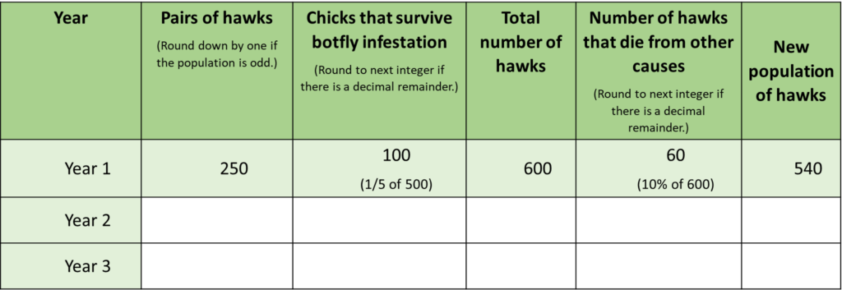

**How long will it take for the population of Ridgeway’s hawks to exceed 700?**

*(Use the space above to extend the table)*