**Learning Objective**

We are learning how to solve a natural world problem by using and applying our skills of number and identifying patterns.

**The Problem:**

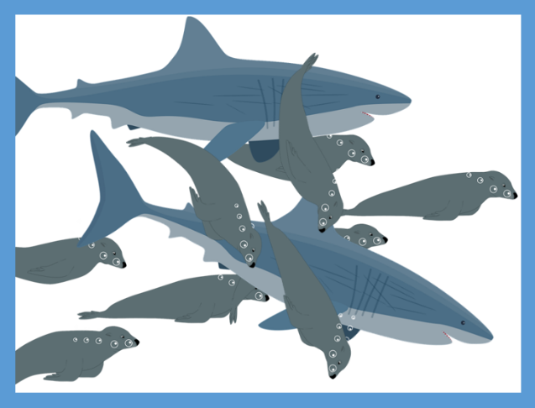In a great white shark’s hunting ground, there are 100 seals.

On day 1, the shark kills a seal and another shark joins its hunting ground.

On day 2, both sharks each kill a seal and another shark joins the hunting ground.

On day 3, the three sharks each kill a seal and another shark joins the hunting ground.

This pattern continues.

**Can you construct a table to show how the number of seals and sharks change over time?**

**Recording: (Use this space to construct your table)**

Use your table to answer the following questions:

1. **How many sharks were there on day 4? ________**
2. **How many seals were there on day 5? _________**
3. **How long did it take until there were more sharks than seals?  _________**