**Learning Objective**

We are learning how to solve a natural world problem by using and applying

our knowledge and understanding of number, multiplication and division.

**The Problem:**

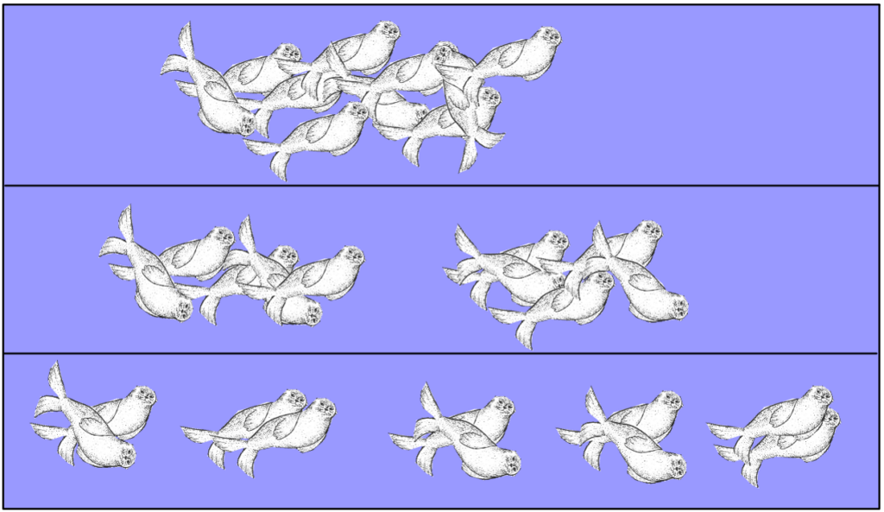After leaving the nursery pool for the open ocean, a pod of fur seals split into **equal** groups. (Swimming in a group, rather than on its own, makes a fur seal less vulnerable to an attack by a predator such as a great white shark.)

A pod of seals with **10** members could divide into equal groups of 2, 5 or 10 to avoid the risk of being eaten by a shark.

**Teacher note:** Groups of 1 aren’t listed due to the seal vulnerability fact mentioned above.

However, there are more options available to a pod of **12** seals as it can divide into equal groups of 2, 3, 4, 6 or 12.

**Which pod size below 50 would offer the fur seals the greatest number of equal group options?**

**Recording:**

*Use this space to show your working out.*

**Answer: A pod size of ______________ would offer the fur seals the greatest number of equal group options.**