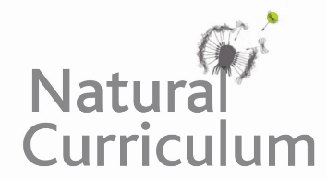**Learning Objective**

We are learning how to solve a natural world problem by using and applying our skills and knowledge of number and addition, measurement and distance.

**The Problem:**

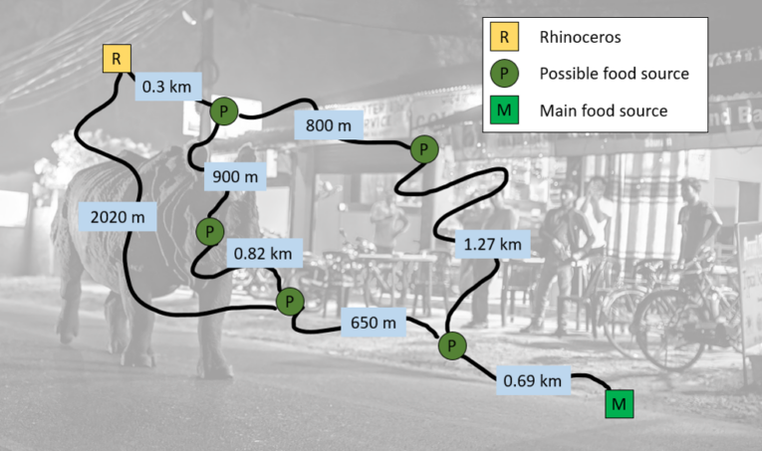A greater one-horned rhino is walking through the streets of Sauraha, Nepal, in search of food. On the map opposite, you can see the starting location of the rhino (R), and the location of the main food source (M). Other possible food sources are also marked on the map (P) along with distances from one location to another.

**If the rhino takes the shortest route to the main food source, how far will it have walked?**

**Recording:**

*Use this space to show your working out.*

**Answer:**

The rhino will have walked a distance of ______________________ .