**Learning Objective**

We are learning how to solve a natural world problem by using and applying our knowledge and understanding of number and place value.

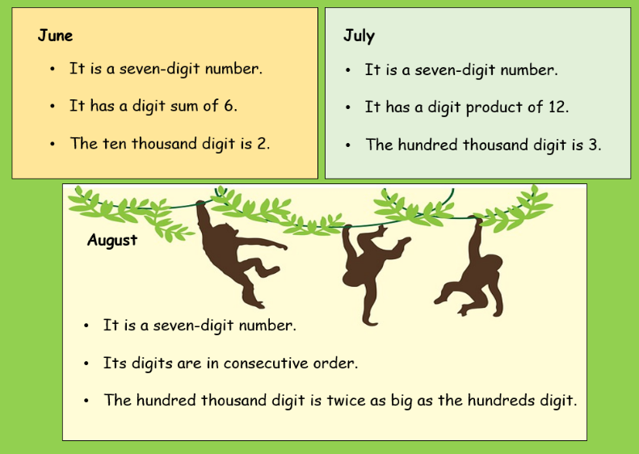**The Problem:**

In Uluwatu temple, a large troop of long-tailed macaques stole expensive items (mobile phones, jewellery and watches) from unsuspecting tourists over a 3-month period.

**Using the clues opposite, can you calculate the highest and lowest possible value of goods stolen over the 3-month period?**



**Recording:**

*(Use this space to show your working out.)*

**Answers:**

The highest possible value of items stolen is Rp _____________

The highest possible value of items stolen is Rp _____________