**Learning Objective**

We are learning how to solve a natural world problem by using and applying our knowledge and skills of statistics and line graphs.

**The Problem:**

An Amur leopard has set off from a mountain cave to cross its territory. It is travelling at a constant **5 miles per hour**. After an hour of travelling, it rests for **an hour**. It continues on in this manner.

**How far will the leopard have travelled after eight hours? ___________**

**Can you create a table to show the distance travelled by the leopard in this time?**

**Can you use your table to complete the line graph (below)?**

**Recording:**

(Use this space to create the table and complete the line graph.)

Title: ______________________________

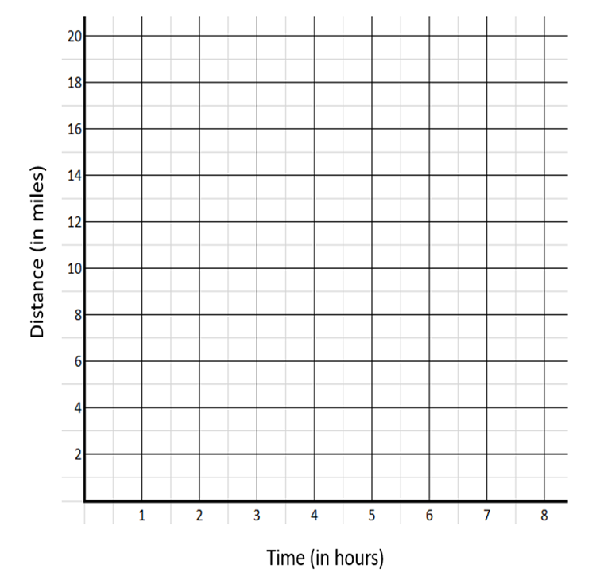

An hour later, the Siberian tiger sets off across the same territory from the same starting point. It travels at a steady **3 miles per hour** without pausing to rest.

Using the same time/distance line graph (above), plot the journey of the tiger and use the graph to answer the questions below:

* **How far will the tiger have travelled in 8 hours?**
* **How long will it take for the tiger to catch up with the leopard?**