**Learning Objective**

We are learning how to solve a natural world problem by using and applying our knowledge and skills of frequency tables and logical thinking.

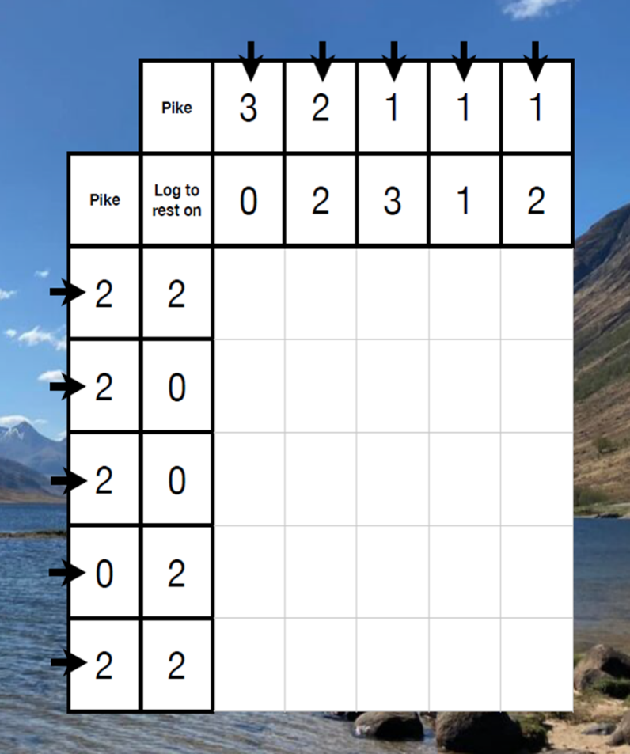

**The Problem:**

Wendy the water vole is on a journey across a loch. She must watch out for pike lurking in the water that could easily swallow her whole. Fortunately, there are some logs floating on the water’s surface that she can rest her weary body on.

Look closely at the grid opposite. You’ll notice that the number of pike and the number of logs in each column and row have been indicated.

**Using the letter P (for pike) and L (for log), can you complete the grid?**

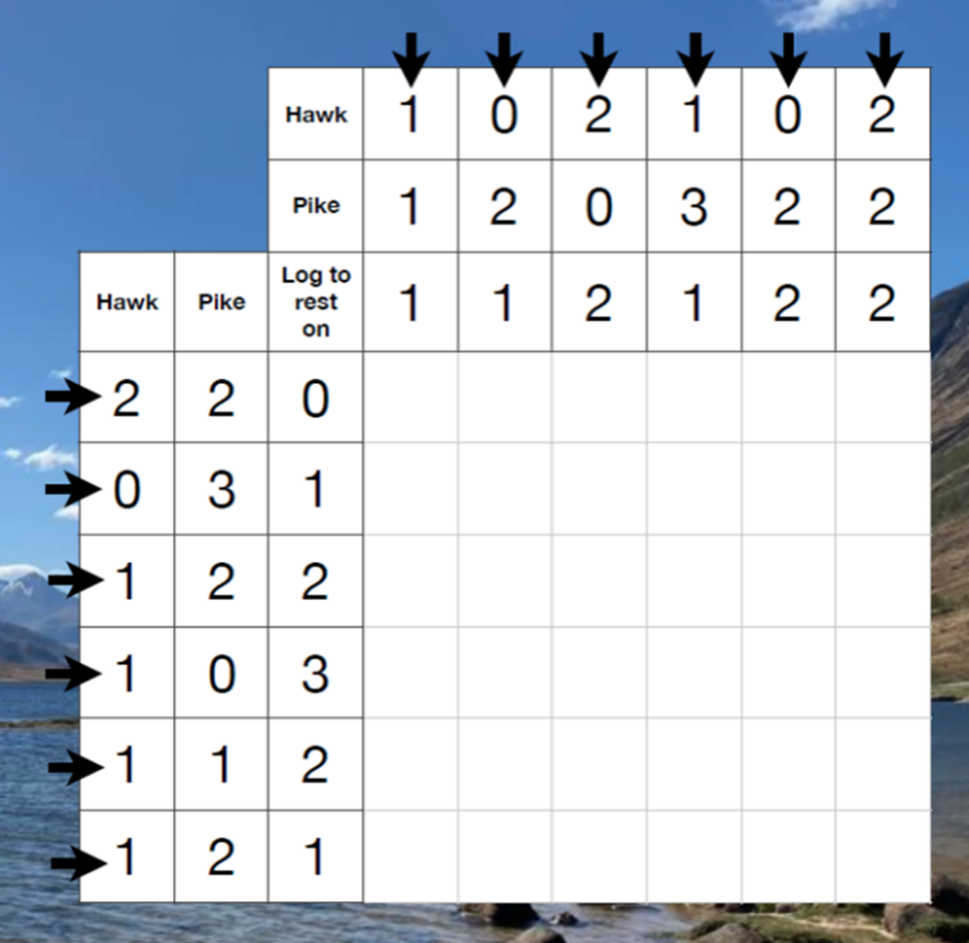

**Further Challenge**

A week later, Wendy swam across a different loch. On this journey, she faced the threat of being caught by a hawk from above.

**Using the letters P (for pike), L (for log) and H (for hawk), can you complete the grid**