**Learning Objective**

We are learning how to solve a natural world problem by using and applying our skills and knowledge of numberand multiplication.

**The Problem:**

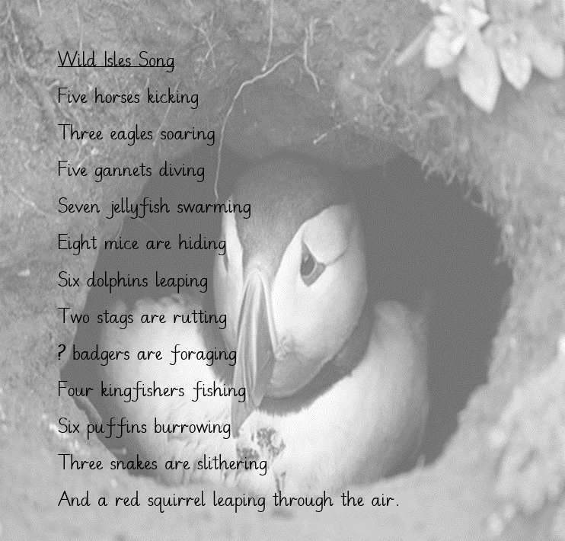

Inspired by her love for wildlife, mathematics and music, Miss Starling wrote a song. You can see her song opposite. It features some of the animals that were on show in the Wild Isles trailer and the number of each animal species that she had seen for herself whilst travelling around the UK.

Miss Starling recorded a total of **108 animal legs** in her song!

**How many foraging badgers did Miss Starling see?**

**Recording:**

Use this space to show your working out*.*

**Answer: ______________** badgers

**Now compare your working out to a partner’s, and explore the reasons for any similarities and/or differences.**