**Learning Objective**

We are learning how to solve a natural world problem by using and applying our skills and knowledge of number**,** addition and subtraction.

**The Problem:**

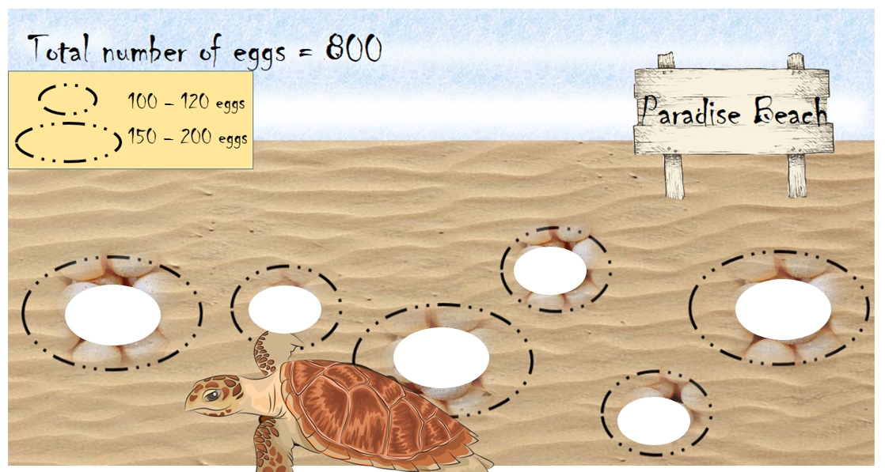Hope, the hawksbill turtle, laid a total of 800 eggs in 6 different nesting sites on Paradise Beach in Australia. There was a different number of eggs in each nesting site.

The nesting sites are shown in the picture opposite. The larger nesting sites contained between 150 and 200 eggs. The smaller nesting sites contained between 100 and 120 eggs.

**How many eggs might Hope have laid in each of the six nesting sites?**

**Recording:**

***Use this space to show your working out.***

**Answer:**

Write your solution in the spaces provided on the picture.

**Once you have found a solution, compare it to a partner’s. What do you notice?**