**Learning Objective**

We are learning how to solve a natural world problem by using and applying our skills and knowledge of statistics and line graphs.

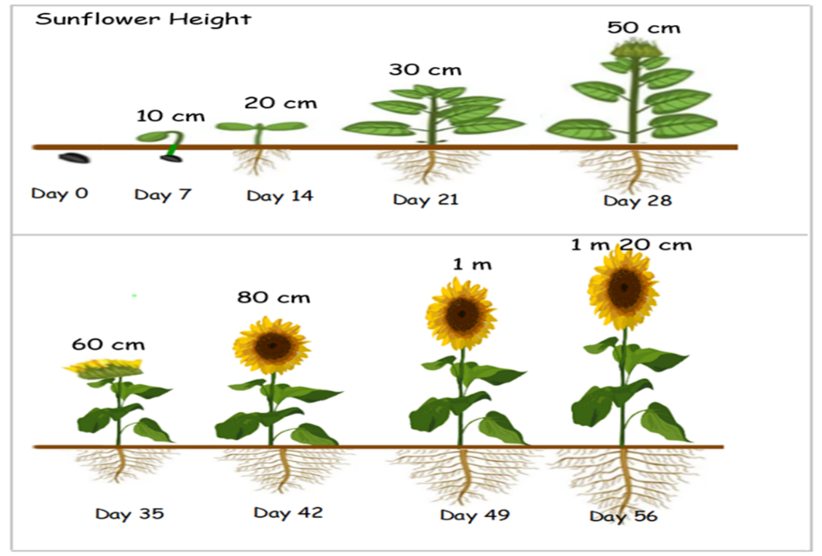

**The Problem**

**Orchard Primary’s eco club grew a sunflower in the hope of attracting more wildlife into their school garden. Iskra and Benji made a series of sketches that showed the height of the sunflower as it grew from a seed into a mature plant (see opposite).**

**What might a line graph that shows how the sunflower’s height changed over time look like?**

Title:

