**Learning Objective**

We are learning how to solve a natural world problem by using and applying our skills and knowledge of geometry and coordinates.

**The Problem**

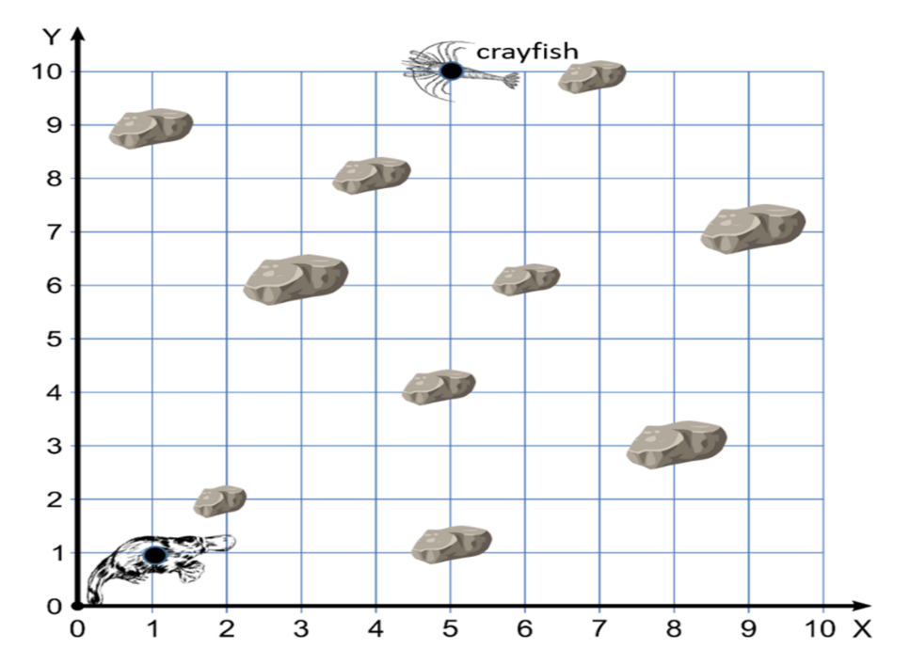

Plato, the duck-billed platypus, was searching for tasty crayfish on a riverbed. The grid opposite shows Plato’s position on the riverbed and a crayfish that he was hoping to catch. It also shows the location of 10 large stones.

**Recording:**

**Using your knowledge of coordinates, can you describe a route that will enable Plato to catch the crayfish without bumping into any stones?**

**Using your knowledge of coordinates, can you describe the shortest route that will enable Plato to catch the crayfish without bumping into any stones?**