**Learning Objective**

We are learning how to solve a natural world problem by using and applying our skills and knowledge of number **(including addition of single and double digit numbers).**

**The Problem:**

Saffi the Sifaka lemur leapt from tree to tree, searching for food in what remained of her Madagascan forest. One evening, she leapt a total distance of **52 metres**.

Using the map below, see if you can you work out the route tha Saffi took through the forest. (Remember – she did not return to trees already visited.)

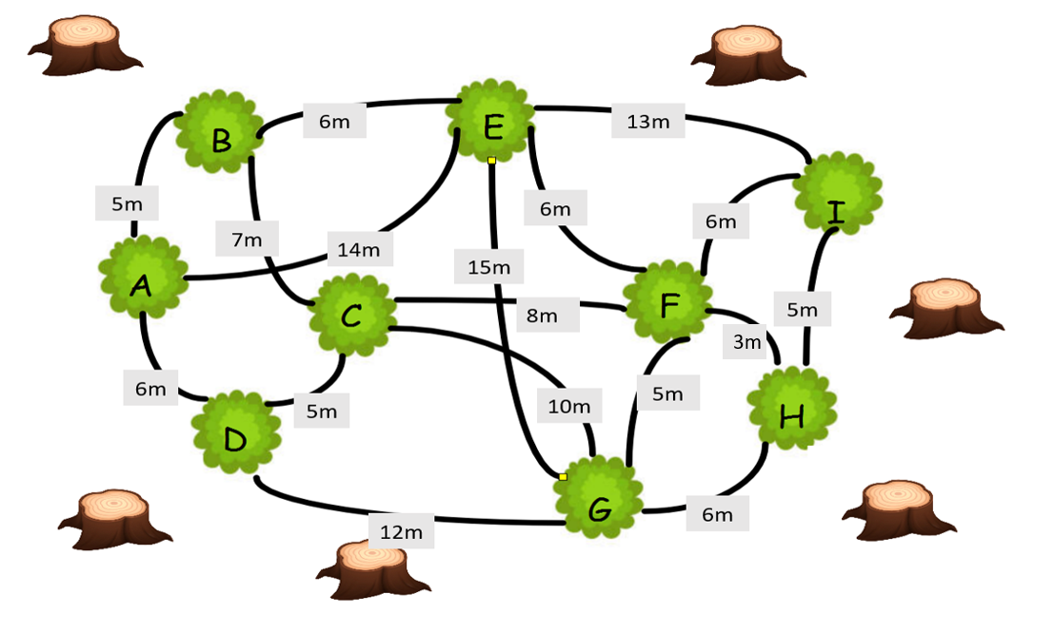

**Use this space to show your working out.**

**My Answer:**

Total: __________________

Total: __________________

I think Saffi leapt on and off the following trees in the following order:

___________________________________________________________