**Learning Objective**

We are learning how to solve a natural world problem by using and applying our skills and knowledge of measurement, mass and weight.

**The Problem:**

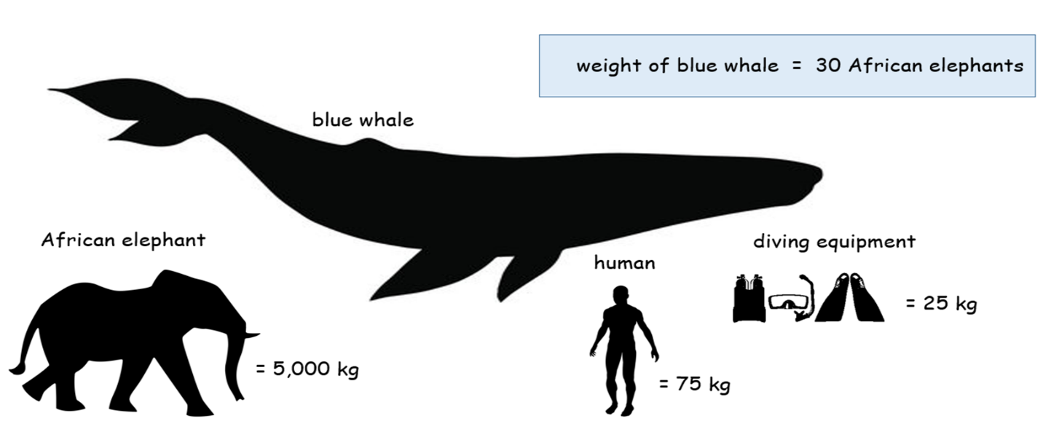After watching the film clip, Benjamin was curious to know how many scuba divers would have the same mass as a blue whale.

**Can you help Benjamin find an answer to this question by using the mass information featured in the infographic above?**

**Recording:**

***(Use this space to show your working out.)***

**Answer:**

**A blue whale has the same mass as _____ scuba divers.**

**Compare your answer to a classmate’s**.  **Can you give reasons for any similarities or differences?**