**Learning Objective**

We are learning how to solve a natural world problem by using and applying our skills and knowledge of number and fractions.

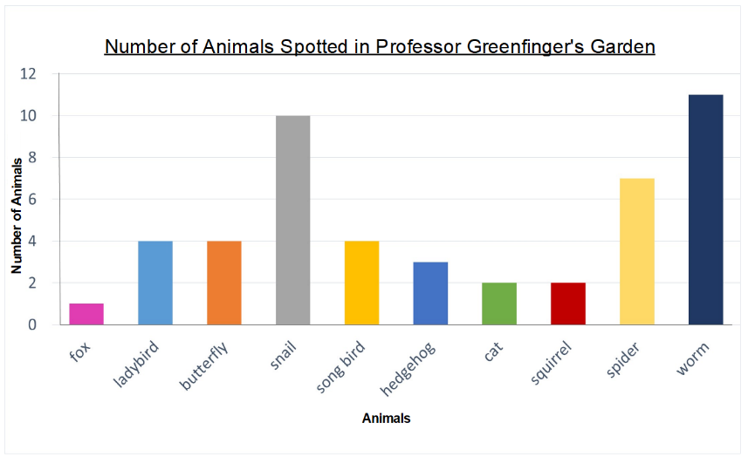**The Problem:**

Professor Greenfingers drew a bar chart to show the number of vertebrates and invertebrates that he spotted in his garden one summer’s day.

As a keen mathematician, he decided to record some statements (below) about the animals that he spotted using his knowledge of number and fractions.

**Which of the professor’s statements are true? Which are false? How do you know?**

Professor Greenfinger’s statements:

(*Circle if you think the statement is true or false.)*

“A quarter of all the invertebrates that I spotted were spiders.” **True False**

“Three quarters of all the animals that I spotted were invertebrates.” **True False**

**Recording:**

Use this space to show your working out.