**Learning Objective**

We are learning how to solve a natural world problem by using and applying our skills and knowledge of number and place value.

**The Problem:**

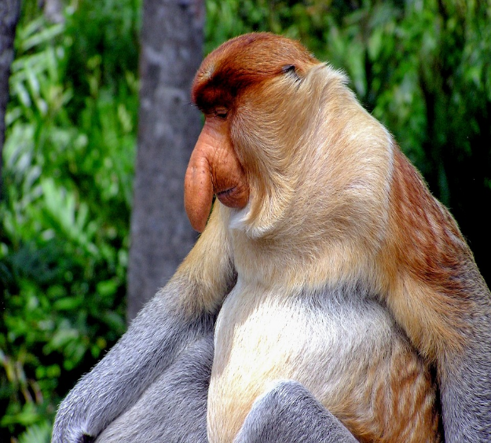Logan loves playing Top Trumps, so he began to create his own set of Marvellous Monkeys Top Trumps cards. To complete the cards, Logan needs to give each monkey species**a rating out of 100** that reflects its weight, speed, length and life span in comparison to other monkey species.

**Can you complete Logan’s six Top Trumps cards by using the information in the table below?**

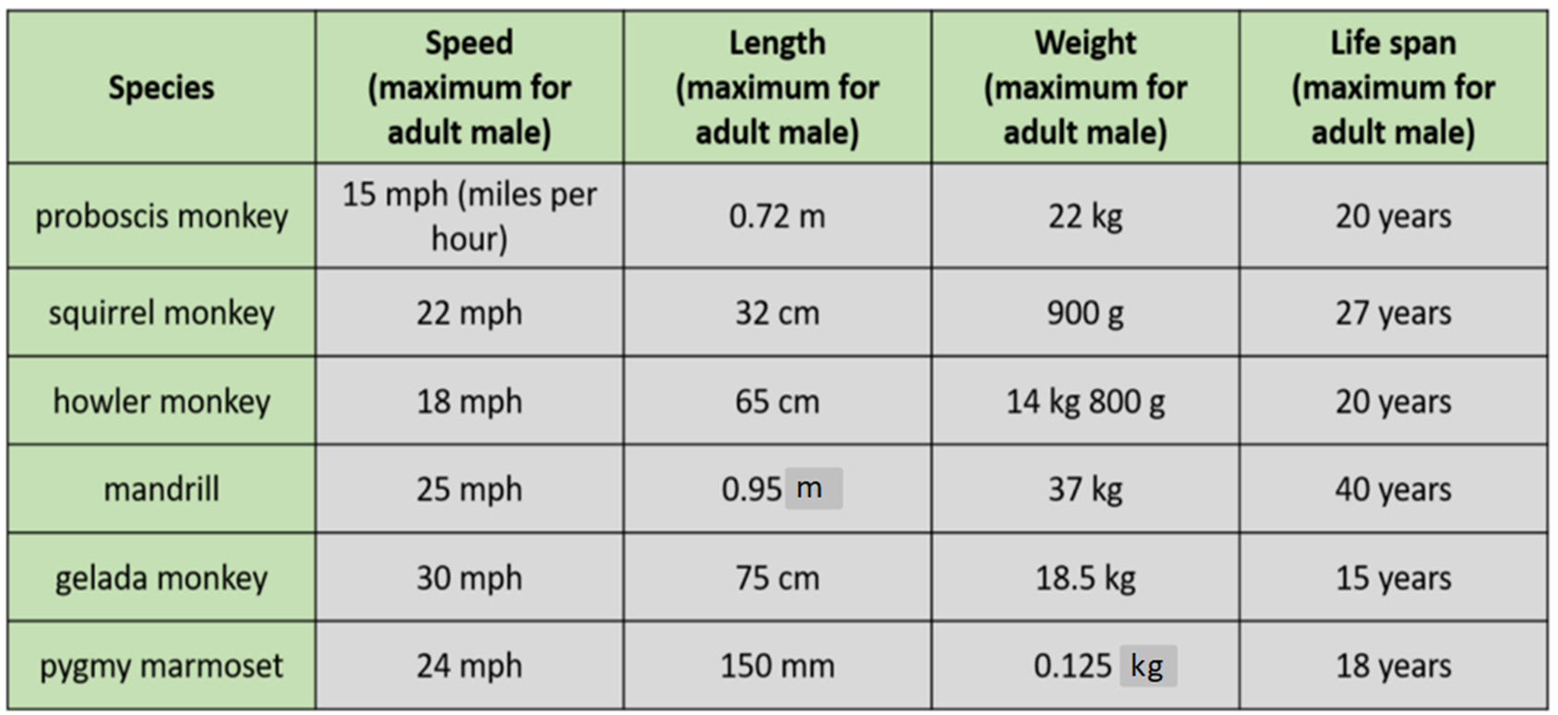

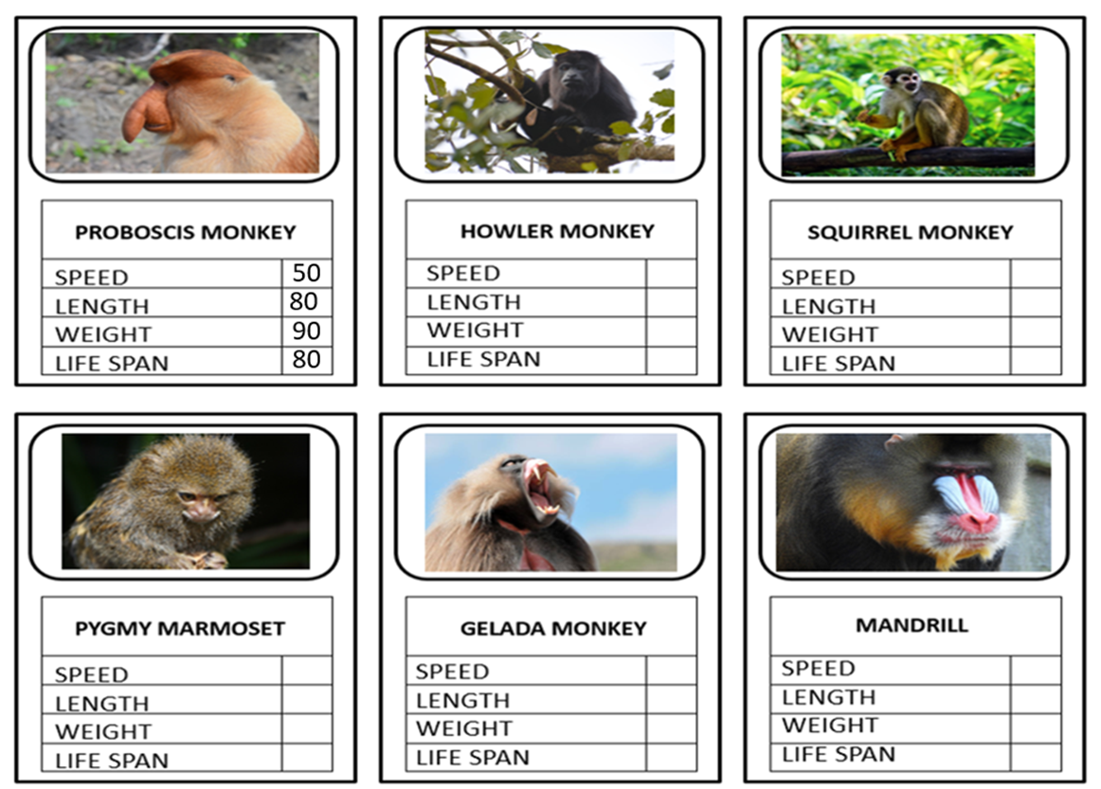**Marvellous Monkeys Top Trumps cards:**

**How do your ratings compare to a friend's? Explore the reasons for any similarities and differences.**