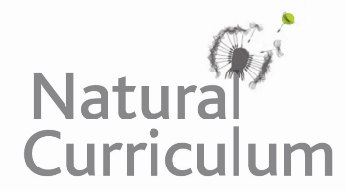**Learning Objective**

We are learning how to solve a natural world problem by using and applying our skills and knowledge of measurement, weight and mass.

**The Problem**

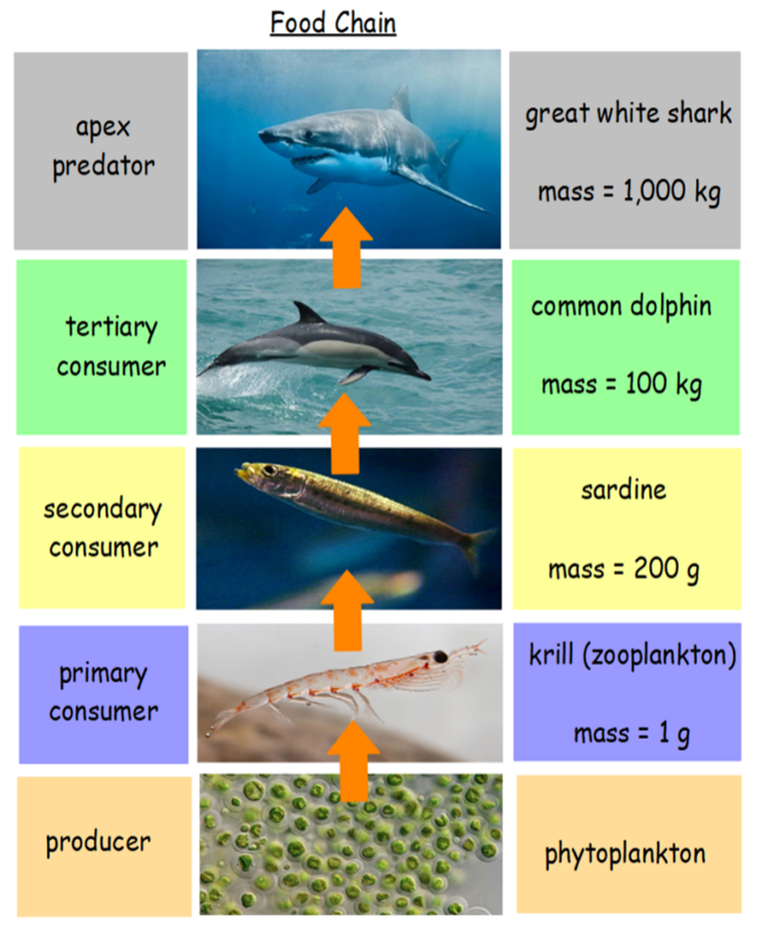One evening, in the Pacific Ocean, a great white shark caught and ate a common dolphin. That same day, the common dolphin had eaten 5 sardines. Each sardine had eaten 50 krill (a type of zooplankton) and each krill had eaten half its weight in phytoplankton (microscopic plants).

**Can you calculate the total mass of all the plants and animals in this ocean food chain?**

**How will you make sure that you don’t miss out any plants or animals from your calculation?**

**Recording**

*Use this space to show your working out.*

**Answer:** The total mass of all the plants and animals is ___________ .