**Learning Objective**

We are learning how to solve a natural world problem by using and applying our skills and knowledge of measurement and moneyand pounds and pence.

**The Problem:**

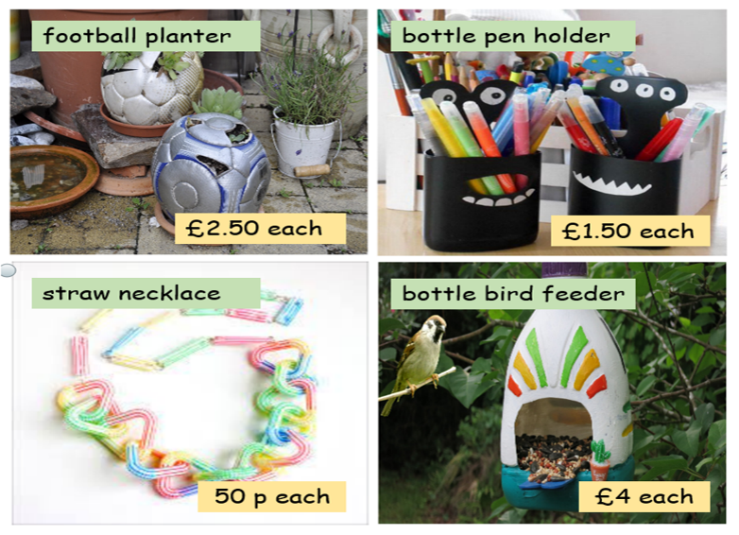

An eco-craft fair was due to be held in Orchard Primary’s school hall. The school needed to raise **£50** from the fair so that they could construct a [plastic bottle greenhouse](https://schoolgardening.rhs.org.uk/news/news-results/national/2019/november/re-purpose-your-plastic) in the school garden. Four different craft items, made by members of the school’s eco council, would be on sale at the fair. You can see each item and their price opposite.

**How many craft items would need to be sold to raise the exact money needed for the greenhouse? How many different solutions are you able to find?**

**Recording:** (You might find a table like this one useful when recording your solutions.)

|  |  |  |
| --- | --- | --- |
|  | Number calculations | Number of craft items |
| Solution 1 | (4 x 10) + (4 x 2.5) = 50 | football planter 4  pen holder 0  necklace 0  bird feeder 10 |
| Solution 2 |  | football planter _______  pen holder _______  necklace _______  bird feeder _______ |
| Solution 3 |  | football planter _______  pen holder _______  necklace _______  bird feeder _______ |
| Solution 4 |  | football planter _______  pen holder _______  necklace _______  bird feeder _______ |