**Learning Objective**

We are learning how to solve a natural world problem by using and applying our skills and knowledge of measurement(m & cm) and number.

**The Problem:**

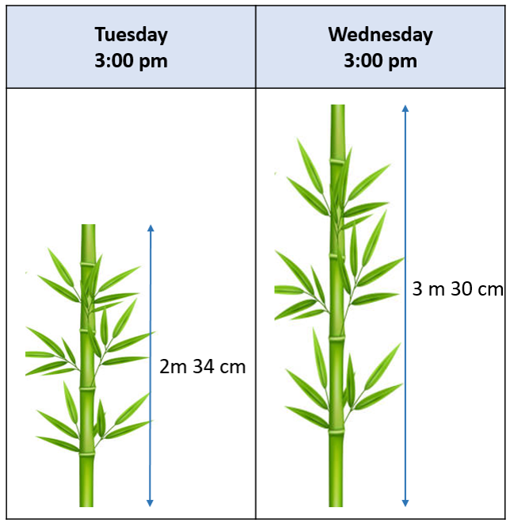Professor Greenfingers decided to calculate the growth rate of the moso bamboo that was growing in his garden. On Tuesday, at exactly 3:00 pm, the height of one particular bamboo stem was **2 m 34 cm**. The following day, at the same time, the bamboo stem measured **3 m 30 cm**.

Professor Greenfingers calculated that the bamboo stem was growing at a rate of **1 cm every quarter of an hour.**

**Do you agree with Professor Greenfingers’ growth rate calculation?**

**How do you know?**

**Recording/Solutions:**

Use this space to show your working out.

**Answer:**

**My calculations show that the Professor’s growth rate was ____________ .**