**Learning Objective**

We are learning how to solve a natural world problem by using and applying our skills of statistics and bar charts.

**The Problem:**

Hassan and Margot’s bar chart looked like this:

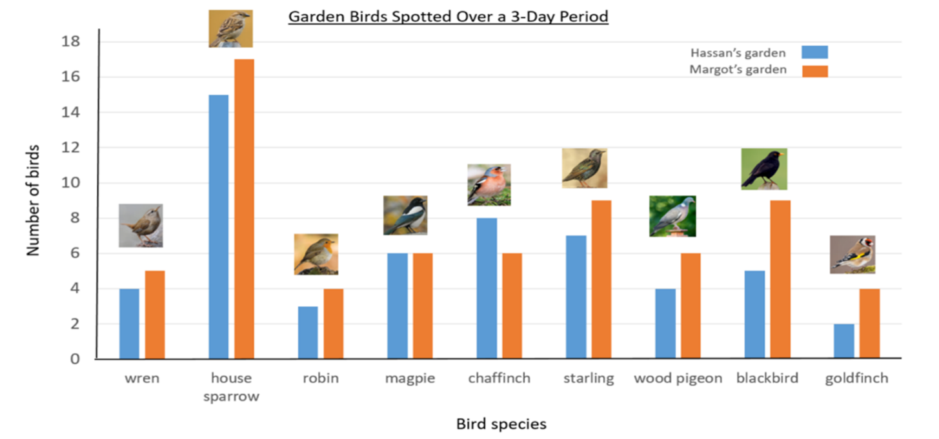 **Discuss with a partner which of the statements below you agree with. Can you explain your reasoning?**

**Hassan’s statements:**

* “We spotted the same amount of magpies.”
* “I spotted five fewer blackbirds in my garden than in Margot’s garden.”
* “Of all the birds spotted in both gardens, the starling was spotted the most number of times after the house sparrow.”

**Margot’s Statements:**

* “The number of wrens and robins spotted in Hassan’s garden was equal to the number of magpies spotted in my garden.”
* “Nine more birds were spotted in Hassan’s garden than in my garden.”
* “One eleventh of all the birds that I spotted were wood pigeons.”