**Learning Objective**

We are learning how to solve a natural world problem by using and applying our skills and knowledge of measurement and area.

**The Problem:**

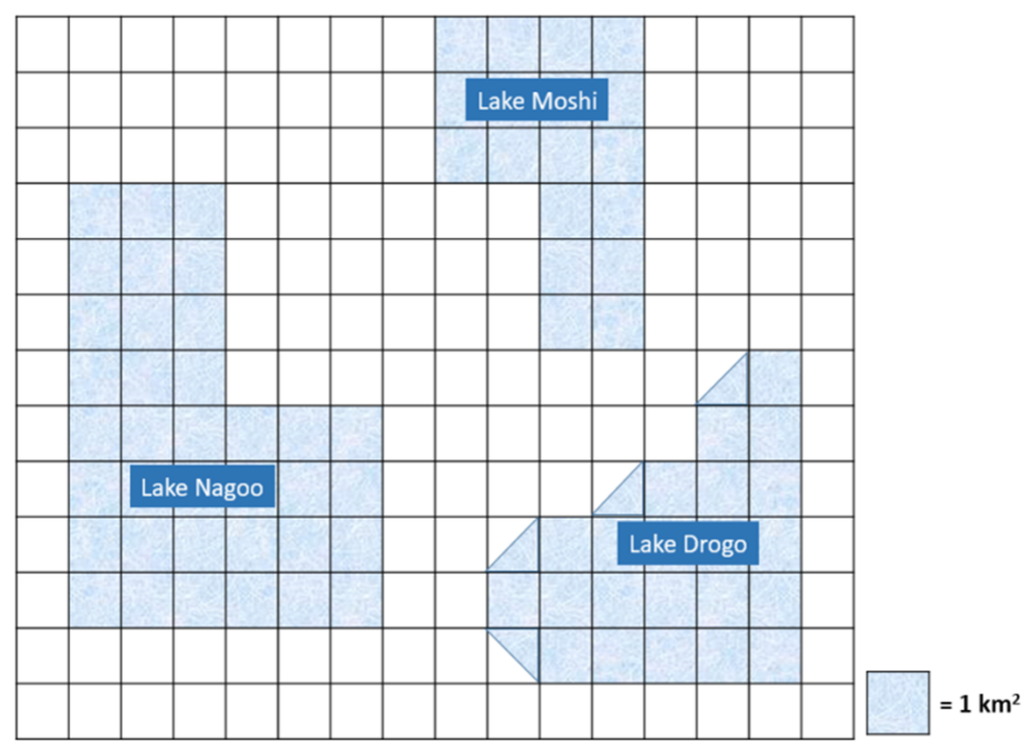There are 3 Lakes – Lake Moshi, Lake Nagoo and Lake Drogo. You can see each lake’s size and shape on the graph paper image opposite. Sadly, the lakes are decreasing in size due to climate change and other human-made factors.

The rates by which each lake is decreasing in size are as follows:

* **Lake Moshi** – 2 square kilometres per year
* **Lake Nagoo** – 4 square kilometres per year
* **Lake Drogo** – 3 square kilometres per year

**Which lake do you think will be the first to disappear? Why do you think that?**

**Recording:**

Use this space to show your working out*.*

**Answer:** I think the first lake to disappear will be ______________ .