**Learning Objective**

We are learning how to solve a natural world problem by using and applying our skills and knowledge of geometry and 2-D shapes.

**The Problem:**

The tortoise discovered by Dr Jones has the following number of scutes on its shell:

* 3 regular hexagons
* 4 irregular hexagons
* 2 irregular quadrilaterals

**Using this information, can you draw what you think the tortoise’s shell might have looked like using the triangular graph paper and the tortoise shell outlines (below)?**

Rules:

1) The scutes must fit together without gaps or overlapping.

2) Only the shapes listed above must appear on the shell.

3) All scute lines must be drawn over the graph paper’s blue triangular lines.

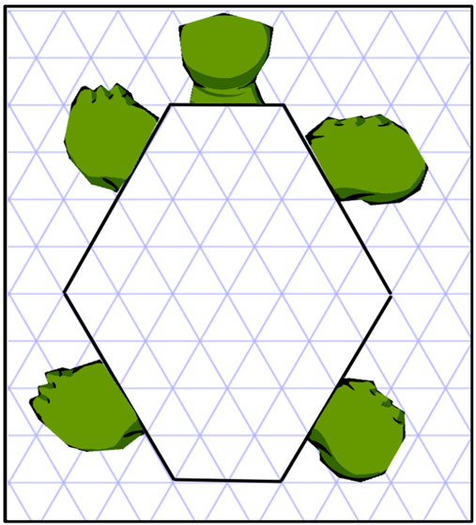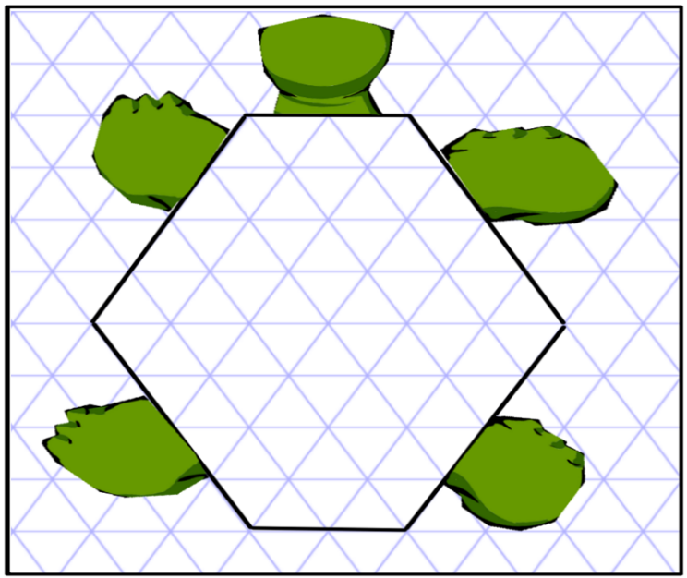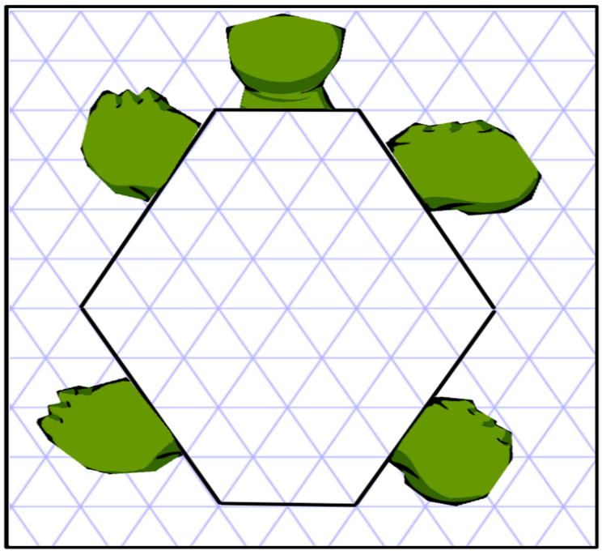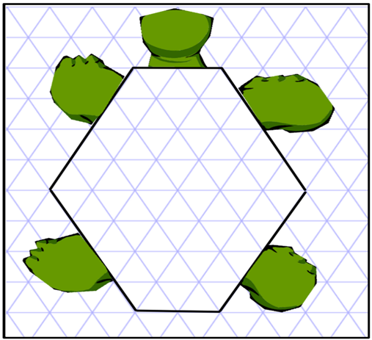

Solution 3

Solution 1

Solution 4

Solution 2