**Learning Objective**

We are learning how to solve a natural world problem by using and applying our skills and knowledge of numberand place value.

**The Problem:**

A team of scientists wanted to know how far some Atlantic salmon had travelled from the sea to their spawning ground in the upper reaches of the River Wye. To do this, they fixed electronic tracking tags to 5 salmon.

They have been ordered according to the distance that each fish swam (see below). Salmon A swam the shortest distance and salmon E swam the furthest. All of the salmon swam a distance that was **greater**than **2,000 km** and **less**than **5,000 km.**

**Can you suggest the distance that each fish swam using the two sets of digit cards (0 – 9)?**You can only use each digit card once.

**Is there more than one solution to this problem? How do you know?**

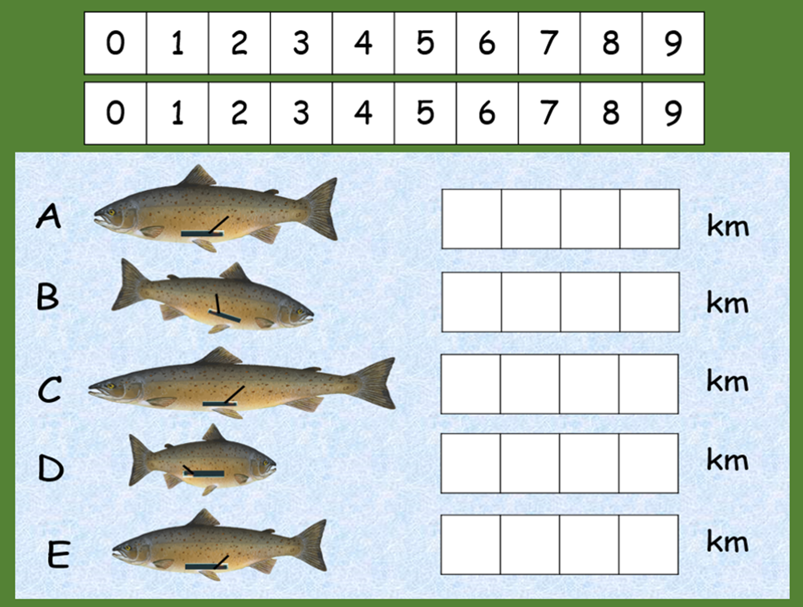**Solution 1:**

**Further Solutions:** (Use this space to record additional solutions.)