**Learning Objective**

We are learning how to solve a natural world problem by using and applying our skills and knowledge of measurement, area and perimeter

**The Problem:**

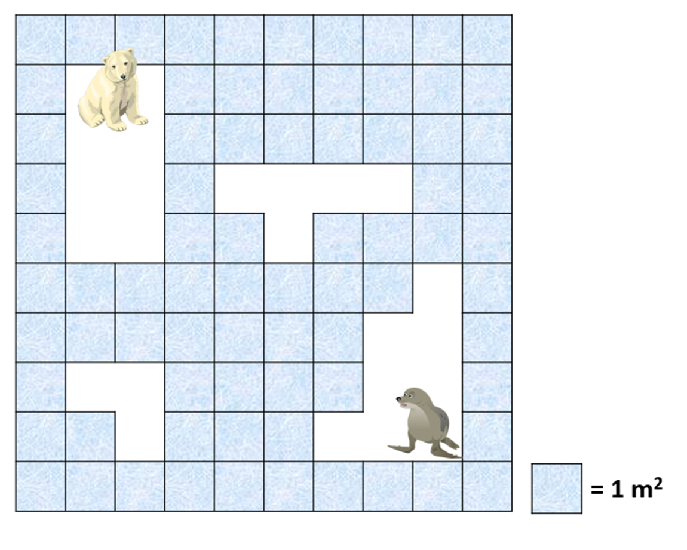Floating on the surface of the Arctic Ocean, a large rectangular ice floe broke into 4 smaller ice floe shapes. These smaller pieces of ice drifted apart and started to rotate. You can see the smaller ice floe shapes in the picture below.

**What was the perimeter and area of the large rectangular ice floe before it broke into the 4 smaller ice floe shapes?**

**Answer: ___________________________________________________**

**Is there more than one solution to this problem? How do you know?**

Cut out the smaller ice floe shapes that appear on the following page and put them together to make one large rectangular ice floe.



