**Learning Objective**

We are learning how to solve a natural world problem by using and applying our skills and knowledge of number**,** addition and subtraction.

**The Problem:**

Professor Greenfingers, a famous mathematician and gardener, was asked to design a flower garden that would attract hummingbirds.

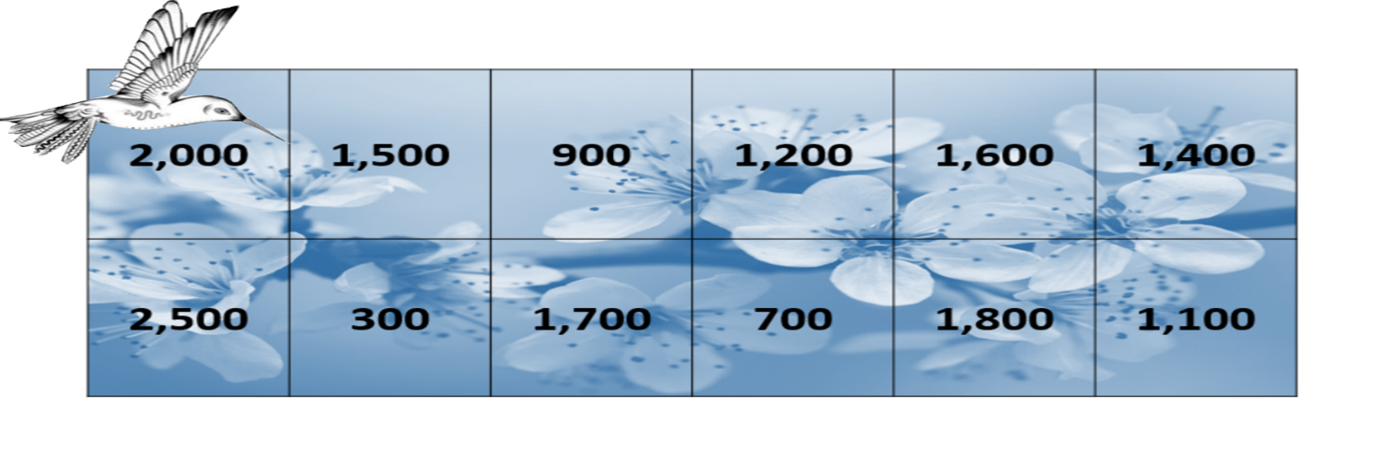When it was finished, a bee hummingbird collected nectar from the garden’s flowers. The number of flowers that it visited each day appear in the list of numbers below.

**If the bee hummingbird visited 10,000 flowers in a single week, how many flowers did it visit each day?**

**Recording:**

Use this space to show your working out and solutions.