**Learning Objective**

We are learning how to solve a natural world problem by using and applying our skills and knowledge of numberand identifying patterns.

**The Problem:**

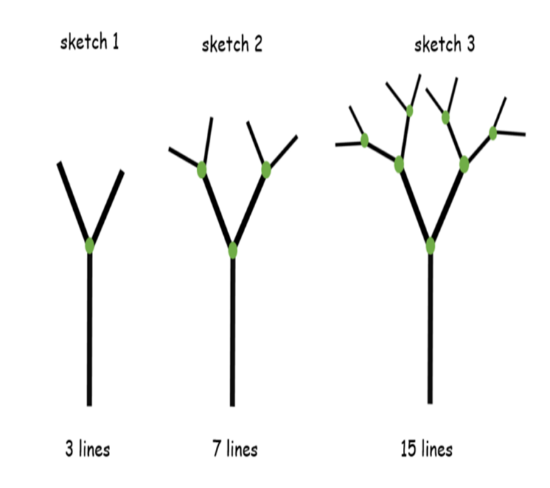Fascinated by the film clip, Ismael decided to construct a simple sketch of a tree using straight lines (see below).

sketch 4

____ lines

**Can you draw a fourth tree sketch? How many lines are there?**

**Using Ismael’s fractal pattern of tree growth, can you work out how many lines would be needed to create a sixth tree sketch?**

**Is it possible to calculate the number of lines without making a tree sketch? How do you know?**

**Recording:**

Use this space to show your working out*.*

**Answer: The sixth tree would be made from _________ lines.**