**Learning Objective**

We are learning how to solve a natural world problem by using and applying our skills and knowledge of numberand multiplication.

**The Problem:**

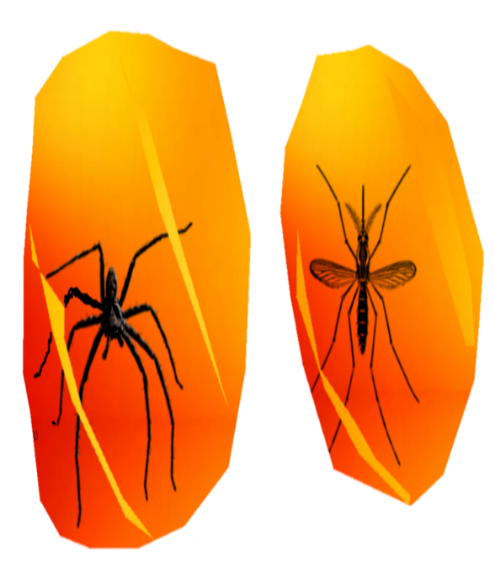Dr Jones, the famous explorer and mathematician, discovered some lumps of amber. Each lump had a single fossilised bug inside it. The bugs were a **mixture** of **six-legged insects** and **eight-legged** arachnids.

Dr Jones decided to count all of the bugs’ legs. He counted**86 legs**in total.

**How many lumps of amber with an eight-legged arachnid inside might he have discovered?**

**How many lumps of amber with a six-legged insect inside might he have discovered?**

**Recording:**

Use this space to show your working out*.*

**Answer: ___________________________________________________**

**___________________________________________________**

**___________________________________________________**

**Can you convince someone that you have found all possible solutions?**