**Learning Objective**

We are learning how to solve a natural world problem by using and applying our skills and knowledge of number**,** multiplication and addition.

**The Problem:**

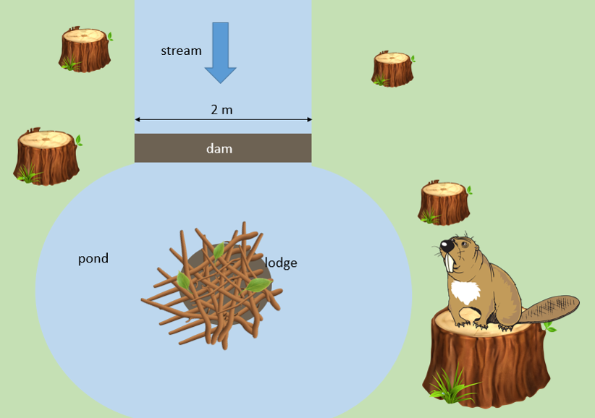Barney the beaver dammed a stream so that he could build a lodge for his family. He used **11 branches** to make his dam. The stream had a width of **2 m.** (You can see a bird’s eye view of the stream, his dam and the family lodge in the picture opposite.) To build the dam, Barney used a mixture of branches of varying lengths. The shortest branch that he used was **40 cm**. The longest branch was **70 cm**. Other branches had lengths of either **50 cm or 60 cm**.

Barney liked arranging his dam branches end to end with no gaps in between, and each row of branches spanned the exact width of the stream. See diagram below.

**How many branches of each length did Barney use?**

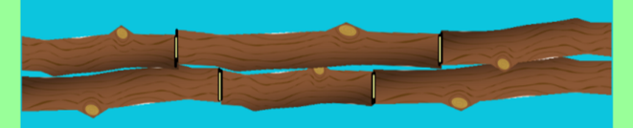

**What might his dam look like?**

**Recording/Solutions:**

Use this space to show your working out and solutions.

**Can you convince a friend that you’ve found all possible solutions?**