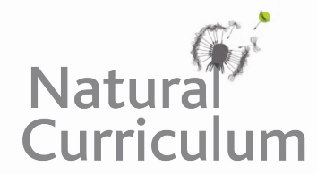**Learning Objective**

We are learning how to solve a natural world problem by using and applying our skills and knowledge of numberand fractions.

**The Problem:**

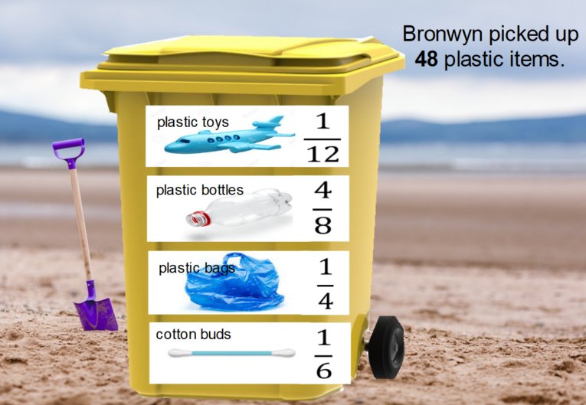Bronwyn, a Year 4 pupil from a school in Bristol, decided that she would like to take part in The Great British Beach Clean. After one hour, Bronwyn had picked up **48 pieces of plastic**. The pieces were a mixture of bottles, bags, cotton buds and toys. She decided to write down the fractions of the different items that she collected. You can see her fractions on the yellow bin opposite.

**Can you convince yourself that Bronwyn’s fractions are right?**

**Compare your working out to a partner’s, and explore the reasons for any similarities and differences.**

**Recording:**

Use this space to show your working out*.*

**Now compare your working out to a partner’s, and explore the reasons for any similarities and/or differences.**