**Learning Objective**

We are learning how to solve a natural world problem by using and applying our skills and knowledge of numberand place value.

**The Problem:**

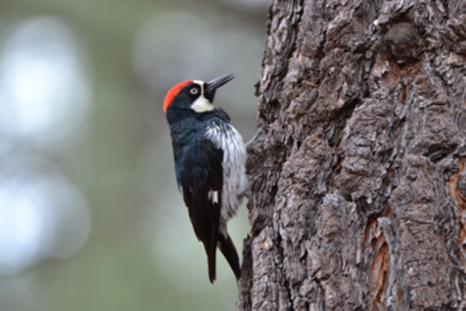A family of 6 acorn woodpeckers hammered thousands of acorns into the small holes that they had drilled into a tree. The exact number of acorns that each woodpecker hammered into the tree is shown in the grid below.

**Can you use the clues to work out the number of acorns that each woodpecker hammered into the tree?**

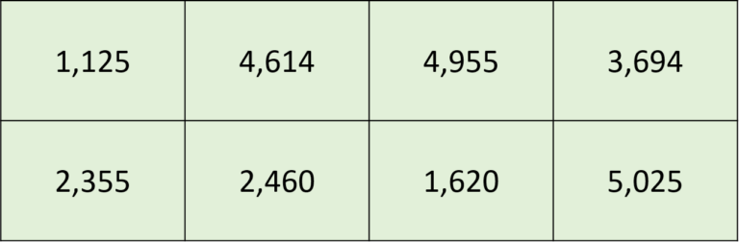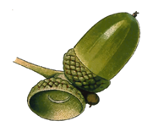

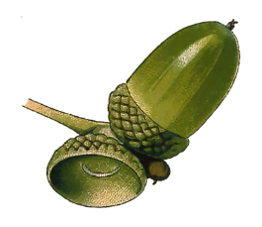

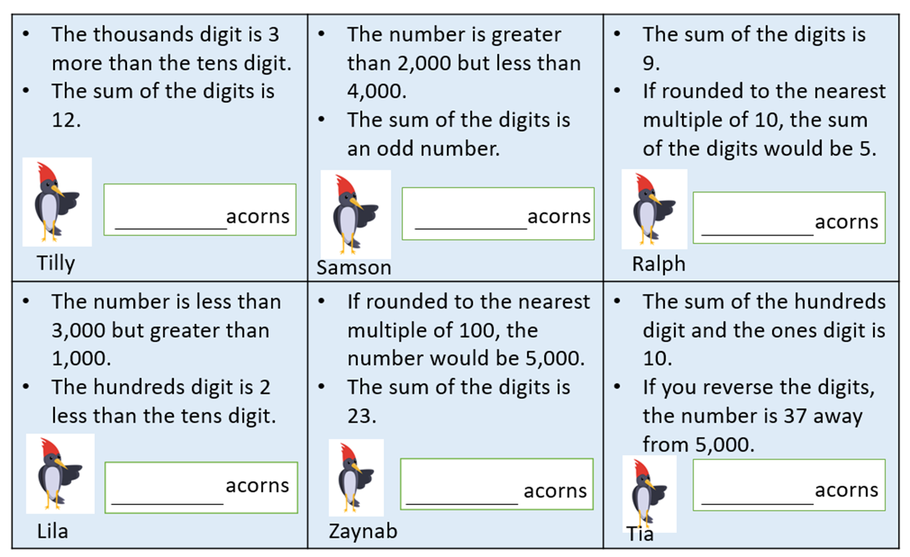Clues:

**Discuss with a partner whether or not you needed to use all of the clues listed above.**