**Learning Objective**

We are learning how to solve a natural world problem by using and applying our skills and knowledge of number, place value andnegative numbers.

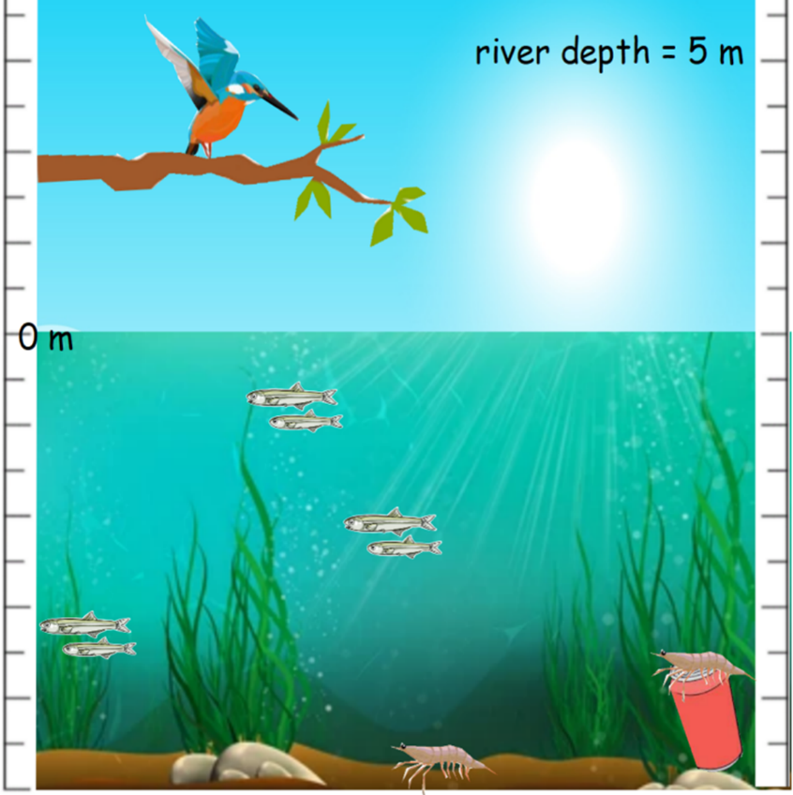**The Problem:**

A kingfisher was sat on a branch that stretched out above a river. It was preparing to catch some minnows (small fish). You can see a picture of the kingfisher opposite with the relative locations of the minnows and other features such as freshwater shrimp and (sadly) a piece of rubbish. You’ll notice that the surface of the river has been marked on a scale as**0 m** and the depth of the river is**5 m.**

Using the information in the picture, work with a partner to answer the questions below.

1. **How far might the kingfisher travel to catch the minnow that is closest to the river’s surface?**

Answer: _________________

1. **How far might the kingfisher travel to catch the shrimp that is on top of the tin can?**

Answer: _________________

1. **How far might the kingfisher travel to catch the minnow that is the closest to the riverbed and then return to the branch**

Answer: _________________