**Learning Objective**

We are learning how to solve a natural world problem by using and applying our skills and knowledge of numberand identifying patterns.

**The Problem:**

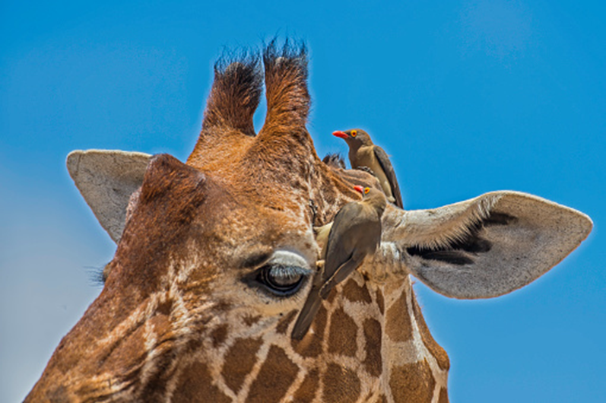

Ollie the oxpecker flew from his nest hole and landed on the back of Gerard the giraffe. After a minute had passed by, Ollie had eaten a total of 2 ticks. After 2 minutes, Ollie had eaten 8 ticks. After 3 minutes, Ollie had eaten 20 ticks, and after 4 minutes, Ollie had eaten 38 ticks.

**Can you suggest the number of ticks that Ollie ate in 10 minutes? How do you know?**

**Recording:**

Use this space to show your working out*.*

**Answer: ______________** ticks

**Compare and explain how you arrived at your number to a classmate.**