**Learning Objective**

We are learning how to solve a natural world problem by using and applying our skills and knowledge of numberand estimation.

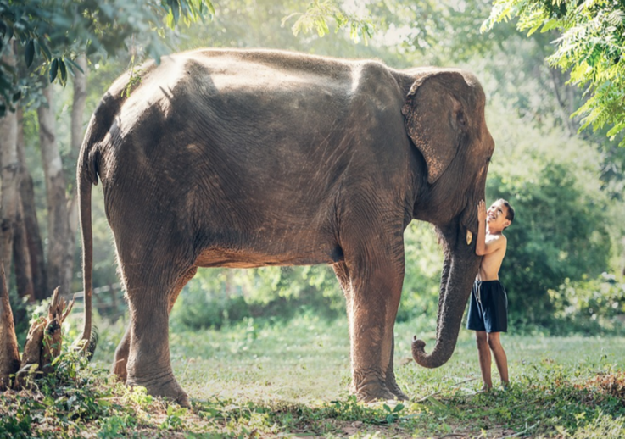**The Problem:**

A Thai boy called Aroon loved visiting Lek’s elephant orphanage at the weekend. His favourite elephant was a large female called Chana. Aroon and Chana can be seen in the photograph opposite. Aroon is **1.2 m** tall.

**Working with a partner, can you estimate the following lengths to the nearest 10 cm?**

1. What is Chana’s height? Estimate: _____________
2. What is the length of Chana’s trunk? Estimate: _____________
3. What is the length of Chana’s tail? Estimate: _____________
4. What is the length of Chana’s right tusk? Estimate: _____________
5. If Chana’s tail and trunk were stretched out, Estimate: _____________

what would Chana’s body length be?

**Recording:**

Use this space to show your working out*.*

**Now compare your estimations to those of another partnership, and explore the reasons for any similarities and differences.**