**Learning Objective**

* We are learning how to recognise and describe the properties of 2D shapes.

**Challenge 1**

**Take a trip into your school grounds and use the table below to record the different 2D shapes that you are able to find. Do the shapes appear as part of living or non-living things? Can you describe the shapes you find using the useful information below the table as a guide?**

|  |  |  |  |  |
| --- | --- | --- | --- | --- |
| **Location of shape** | **Quick sketch** | **Living or non-living** | **Name of shape** | **Description of shape** |
| **e.g.** Front of recycling bin |  | non-living | quadrilateral | no perpendicular sides  4 vertices |
|  |  |  |  |  |
|  |  |  |  |  |
|  |  |  |  |  |
|  |  |  |  |  |
|  |  |  |  |  |

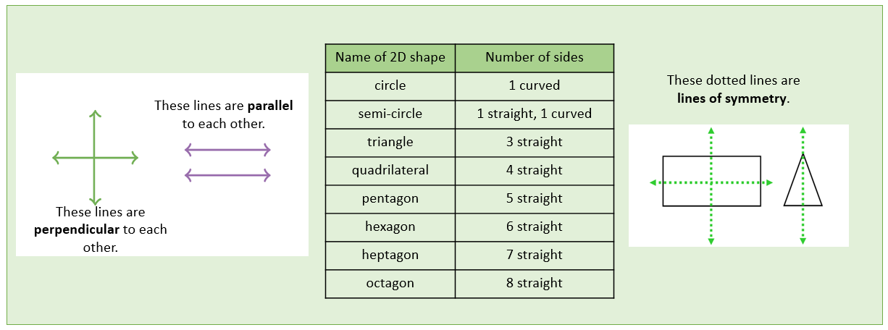**Useful information:**