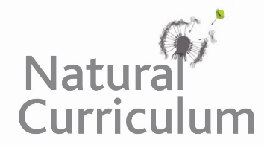**Learning Objective**

We are learning how to solve a natural world problem by using and applying our skills and knowledge of number**,** multiplication and division.

**The Problem:**

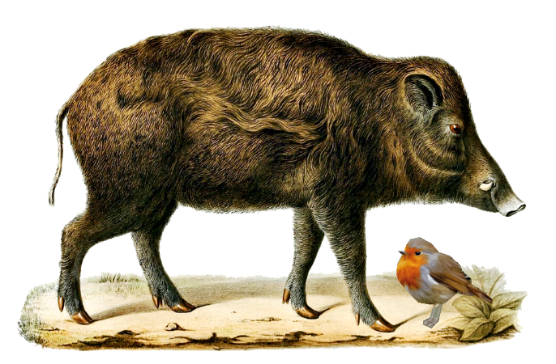**The Problem**

It was April and the snow was long gone. However, the wild boar were still churning up the soil on the forest floor and unearthing lots of delicious worms. Because of this, Rachel the robin managed to find 24 juicy worms. She divided the worms equally among her own chicks and the chicks of Sally the song thrush.

**How many chicks might there have been in Rachel’s nest?**

**How many chicks might there have been in Sally’s nest?**

**Recording/Solutions:**

Use this space to show your working out and solutions.

**Can you convince a friend that you’ve found all possible solutions?**