**Learning Objective**

We are learning how to solve a natural world problem by using and applying our skills and knowledge of numberand estimation.

**The Problem:**

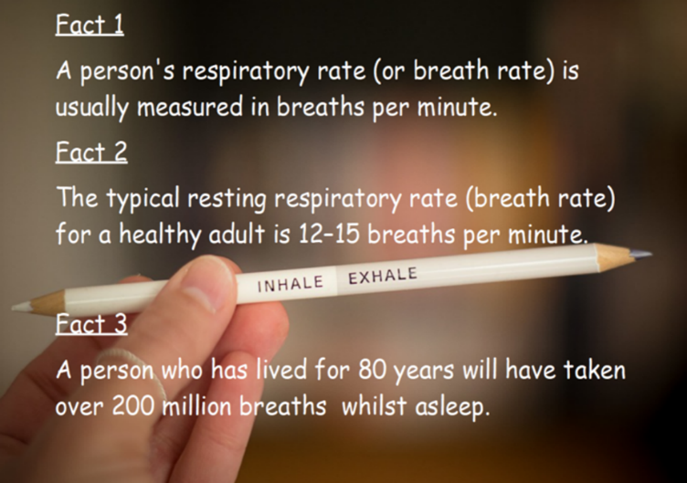Breathing is something that we all do – often without realising it!

**Working with a partner or small group, can you give a reasonable estimate for the amount of times you breathe in and out during the time you spend at school in a single day?**

**Which of these facts might be useful when calculating your estimation?**

**Recording:**

Use this space to show your working out*.*

**Estimation: ______________**

**Now compare your estimation to that of another partnership/group, and explore the reasons for any similarities and/or differences.**