**Learning Objective**

We are learning how to solve a natural world problem by using and applying our skills and knowledge of number, addition and subtraction.

**The Problem:**

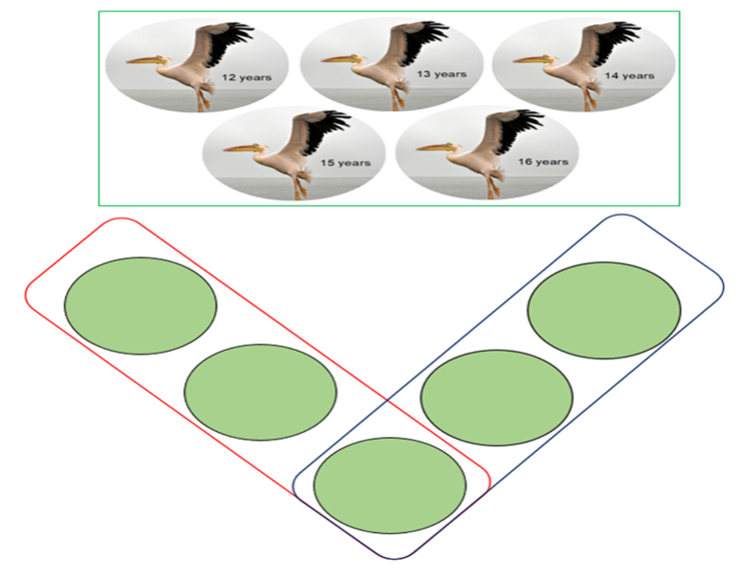

A small flock of 5 pelicans were flying in a V formation. You can see the age of each pelican in the picture opposite.

**Can you arrange the pelicans so that the two arms of the V (the circles inside the red box and the circles inside the blue box) have the same pelican combined-age total?**

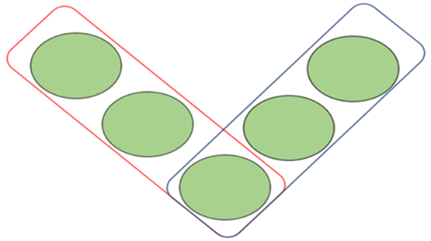**Recording:** (Use the Vs below to record your solutions.)

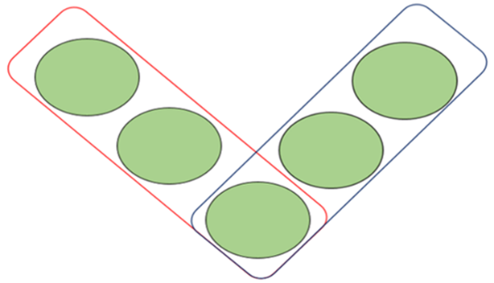





**Can you convince a friend that you have found all possible solutions?**