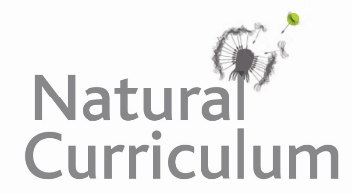**Learning Objective**

We are learning how to solve a natural world problem by using and applying our skills and knowledge of measurement and money.

**The Problem:**

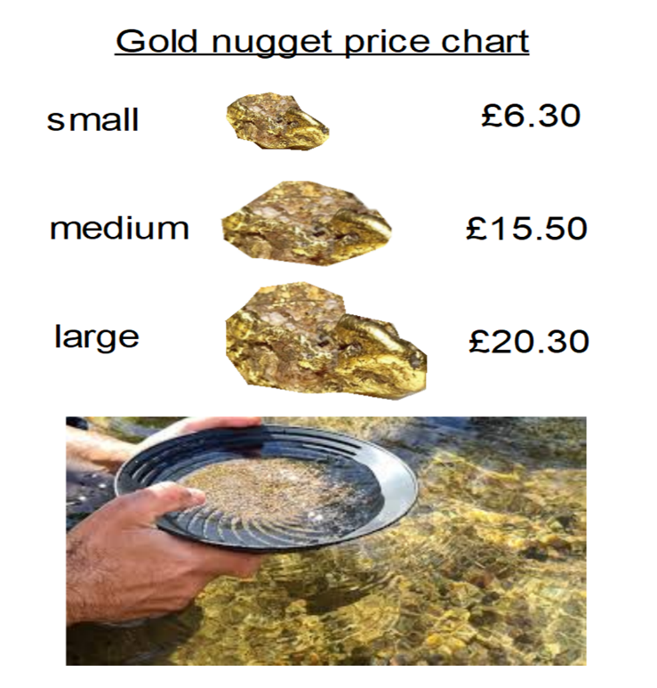

Mr Goldfinger had been given permission to pan for gold in a Scottish stream. After a great deal of patience, he was excited to discover **5** pieces of gold in his pan**! The gold was a mixture** of **small**, **medium-sized** and **large** nuggets. After weighing the nuggets, he calculated that their total value was **£68.70.**

**Using the nugget price chart (opposite), can you work out how many nuggets of each size Mr Goldfinger found?**

**Recording:**

**Answer: ______________________________________**

Use this space to show your working out*.*

**Compare your methodology to a friend’s. What was the same? What was different?**