**Learning Objective**

We are learning how to solve a natural world problem by using and applying our skills and knowledge of numberand identifying patterns.

**The Problem:**

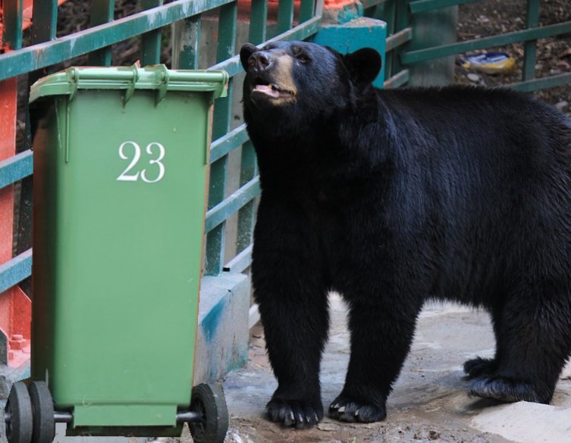One evening, Barney (a 22-year-old black bear) searched for discarded food items in 10 different wheelie bins. However, Barney was a fussy eater, and not every item of food passed his taste test. In fact, Barney took a disliking to one out of every eight food items that he removed from the bins. Each time, he would throw these items on the floor and eat the remaining items.

**If Barney removed 112 items from the bins, how many items did he eat?  How do you know?**

**Recording:**

Use this space to show your working out*.*

**Answer: ______________** food items

**Now compare your working out to a partner’s, and explore the reasons for any similarities and/or differences.**