**Learning Objective**

We are learning how to solve a natural world problem by using and applying our skills and knowledge of number, place value andnegative numbers.

**The Problem:**

Look closely at the thermometer below. Notice the arrows. Each arrow points to a different temperature. These ‘extreme’ temperatures are temperatures that some remarkable animal species can withstand (survive in).

**Can you identify the name of the animal species and the temperature that it can withstand by using the clue cards?**

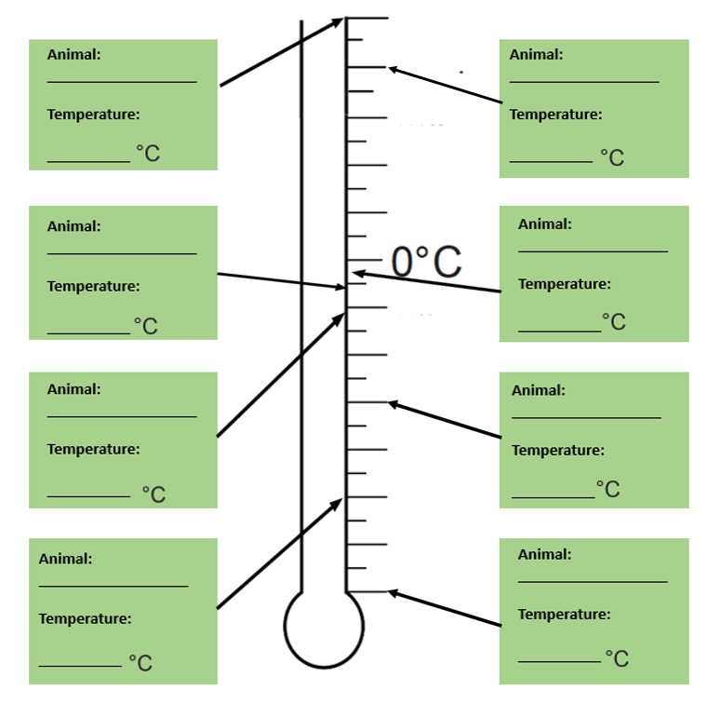

**Recording**

**Extreme Environments clue cards:**

