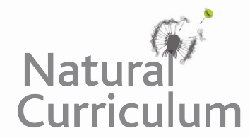**Learning Objective**

We are learning how to solve a natural world problem by using and applying our skills and knowledge of number**,** multiplication and division.

**The Problem:**

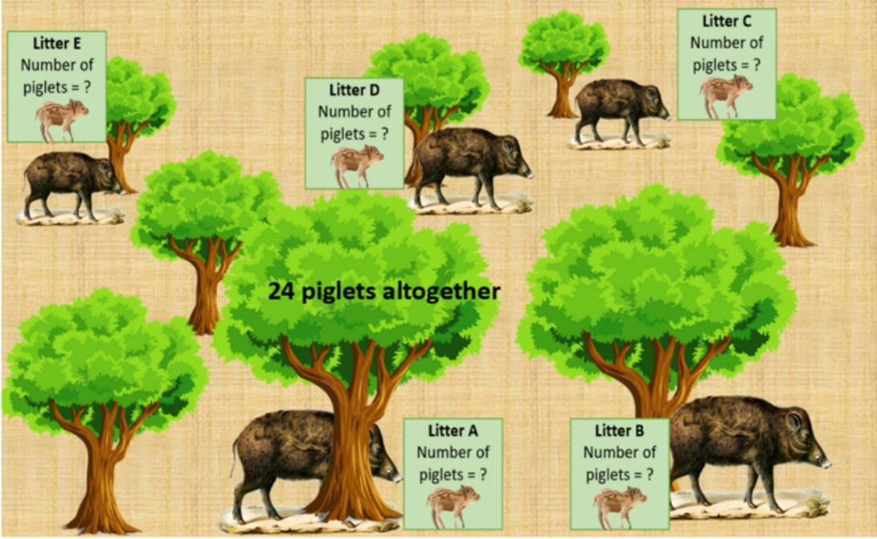In the Forest of Dean, 5 female wild boar have each given birth to a litter of piglets. You can see an illustration of the wild boar and the forest opposite. Each litter (labelled A – E) consists of 4 to 6 piglets.

**If there are a total of 24 wild boar piglets in this area of forest, how many piglets are there in each litter?**

**Is there more than one solution to this problem? How will you prove that you have found all possible solutions?**

**Recording/Solutions:**

Use this space to show your working out and solutions*.*