**Learning Objective**

We are learning how to solve a natural world problem by using and applying our skills and knowledge of length and measurement.

**The Problem:**

The map opposite shows 6 different sites (A, B, C, D, E and F), where the seeds of a saguaro cactus were scattered in the droppings of 6 different animal species. The animals responsible for scattering the seeds were a dove, a tortoise, a woodpecker, a coyote, a bat and an ant.

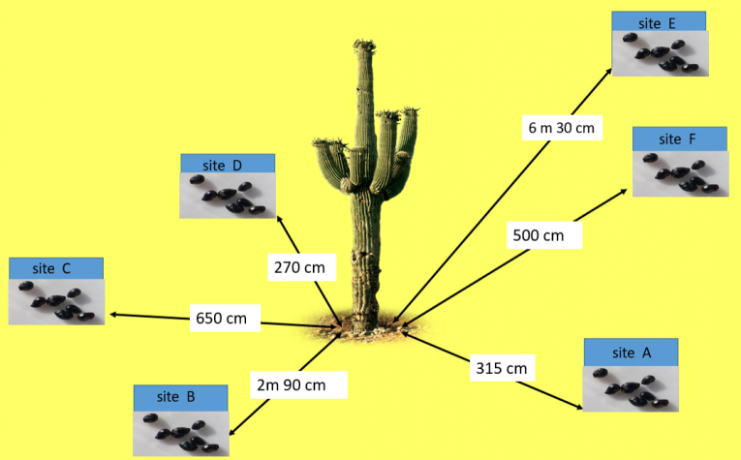

**With a partner, use the clue cards (below) to work out which animal was responsible for which site of seeds.**

**Discuss with your partner whether there were any cards that you didn’t need to use.**

**Recording:**

Use this space to show your working out*.*

**Answers:**

Site A ___________ Site B ____________ Site C _____________

Site D ___________ Site E ____________ Site F _____________



(Cut out the following clue cards.)

