**Learning Objective**

We are learning how to solve a natural world problem by using and applying our skills and knowledge of number and place value.

**The Problem:**

Tia enjoys comparing facts about the different bear species. Tia also loves playing Top Trumps, so she decided to create her own set of *Amazing Bears* Top Trump cards (see below).

**Can you help Tia complete each bear’s standing height rating using the bear height information cards**?

* **Note:** Ratings are scored out of 100.
* **Top tip:** Ordering the cards could be a helpful first step.

Carefully cut out the standing height information cards and *Amazing Bears* Top Trump cards.

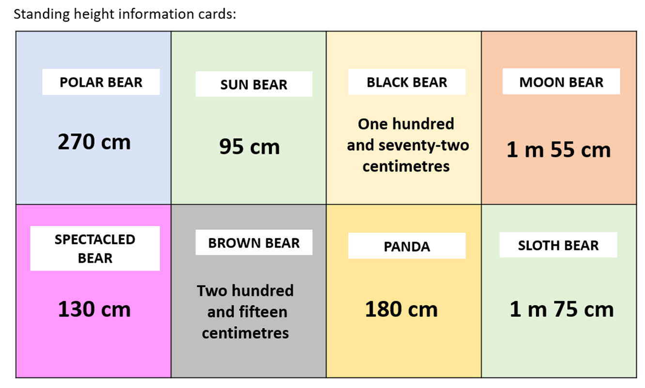

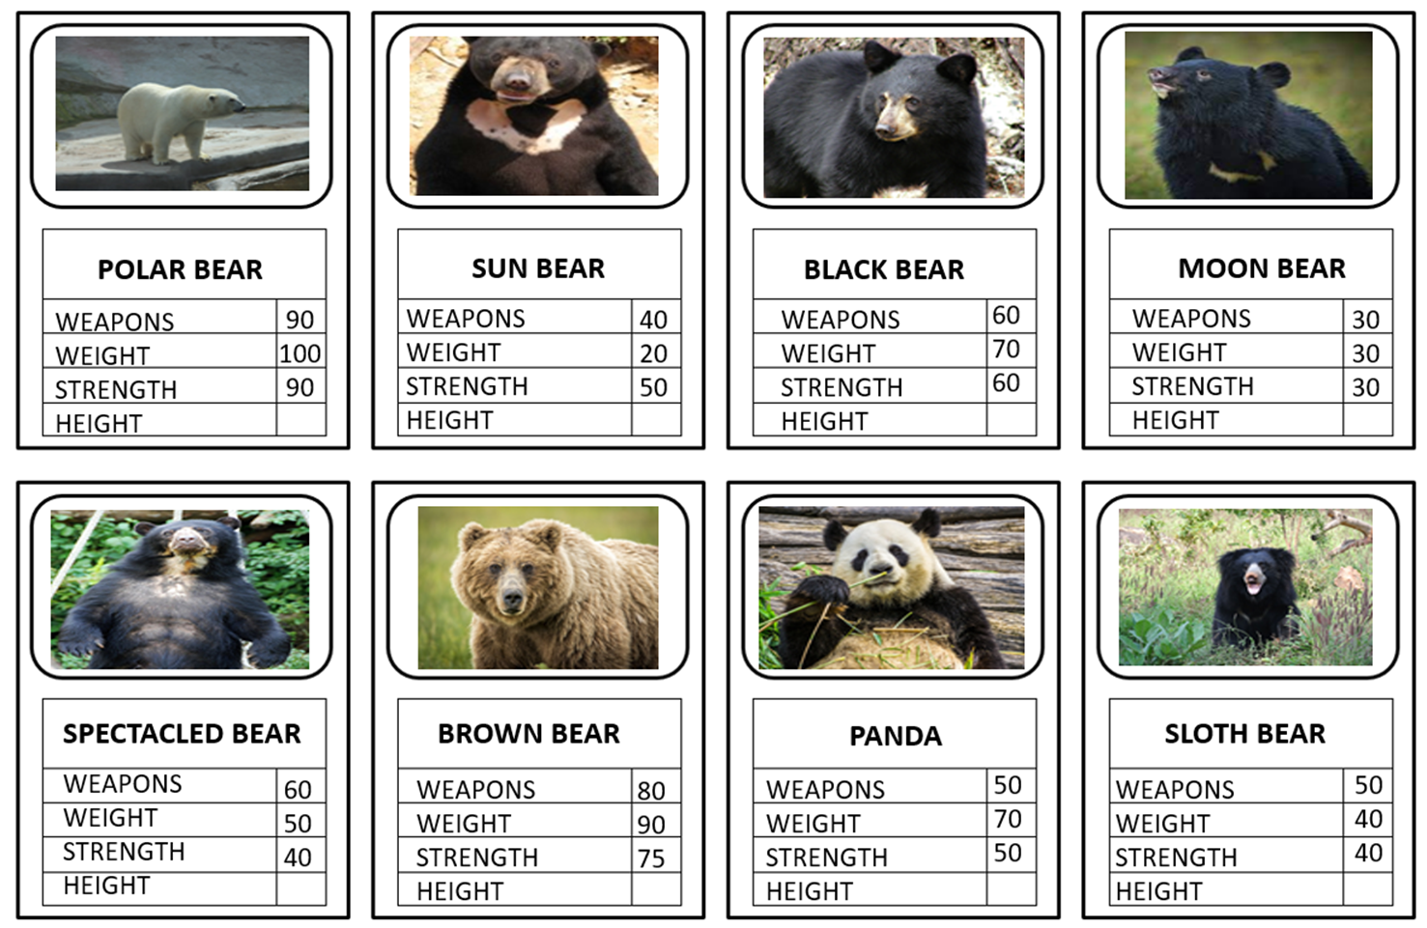

Amazing Bears Top Trump cards