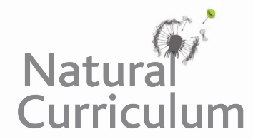**Learning Objective**

We are learning how to solve a natural world problem by using and applying our skills and knowledge of geometry, 2-D and 3-D shapes.

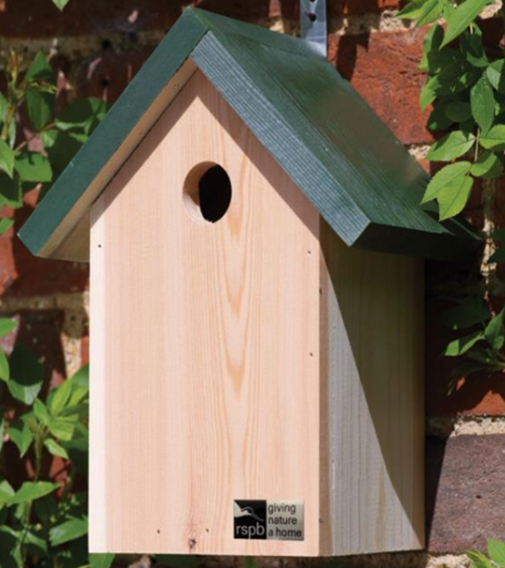**The Problem:**

Here is a photograph of a nest box design that the children in Starlings class thought they could make. You’ll notice that the nest box has been constructed from different pieces of wood, which have been fixed together.

Before they could start sawing their wood into the correct shapes and sizes, the children first needed to draw all of the pieces.

**What do you think the pieces of wood looked like? How accurately are you able to draw them?**

**Recording:**

Draw the shapes on the planks of wood (below) and cut them out. Try to waste as little wood as possible.

