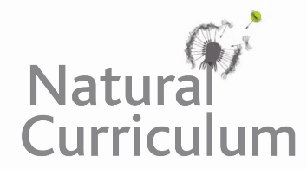**Learning Objective**

We are learning how to solve a natural world problem by using and applying our skills and knowledge of geometry and angles.

**The Problem:**

If you look closely at the veins on the leaf below, you’ll notice that, as they branch out from the main vein, interesting angles are created.

**Can you find and mark on the leaf 5 acute angles?**

**Can you find and mark on the leaf 5 right angles?**

**Can you find and mark on the leaf 5 obtuse angles?**

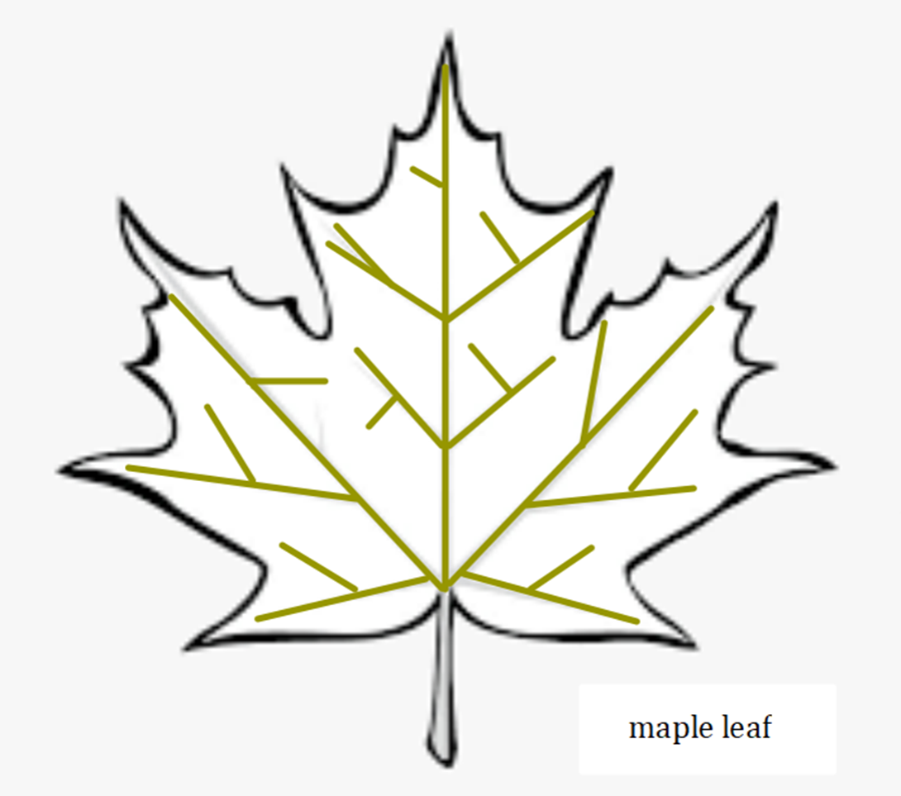

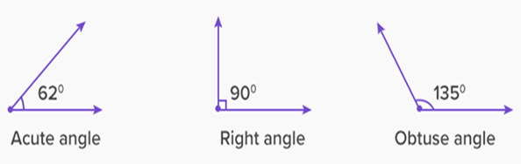

**Can you use this angle guide to estimate the size of the angles that you have found?**