**Learning Objective**

We are learning how to solve a natural world problem by using and applying our skills and knowledge of measurement, weight and mass.

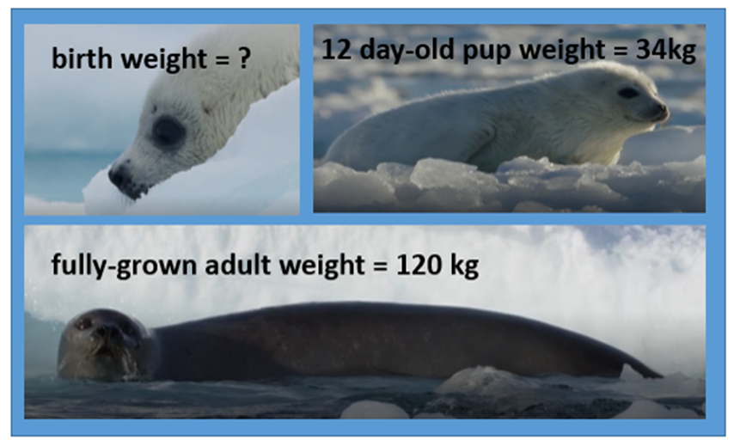**The Problem:**

For12 days after her birth, Harriet was fattened up on her mother's milk. During this time, she put on 2 kg of weight every day. Once the 12 days were over, Harriet weighed 34 kg.

Harriet is now a fully-grown adult. She weighs 120 kg.

**1) What was Harriet the harp seal's birth weight?**

*Use this space to show your working out.*

**Answer:** _____________

**2) Can you work out how many times heavier Harriet's fully-grown adult weight is than her weight at birth?**

*Use this space to show your working out.*

**Answer:** ____________